“Smart Diabetes Risk Predictor: An Interpretable Machine Learning-Based Decision Support System Using Lifestyle and Clinical Data”

Name: W.M.MADEERA SHASHINTHA
London Met ID No: COL00267345

London Metropolitan University

Declaration
Module: CS6P05ES Deadline: 2026/7/15
Module Leader: Student ID: COL00267345
PLAGIARISM
You are reminded that there exist regulations concerning plagiarism. Extracts from these regulations are printed below. Please sign below to say that you have read and understand these extracts:
(signature:)_madeera777@gmail.com Date: 2026/6/29
This header sheet should be attached to the work you submit. No work will be accepted without it.
Extracts from University Regulations on Cheating, Plagiarism and Collusion
Section 2.3: "The following broad types of offence can be identified and are provided as indicative examples…
- Cheating: including taking unauthorised material into an examination; consulting unauthorised material outside the examination hall during the examination; obtaining an unseen examination paper in advance of the examination; copying from another examinee; using an unauthorised calculator during the examination or storing unauthorised material in the memory of a programmable calculator which is taken into the examination; copying coursework.
- Falsifying data in experimental results.
- Personation, where a substitute takes an examination or test on behalf of the candidate. Both candidate and substitute may be guilty of an offence under these Regulations.
- Bribery or attempted bribery of a person thought to have some influence on the candidate's assessment.
- Collusion to present joint work as the work solely of one individual.
- Plagiarism, where the work or ideas of another are presented as the candidate's own.
- Other conduct calculated to secure an advantage on assessment.
(viii) Assisting in any of the above.
Some notes on what this means for students:
1. Copying another student's work is an offence, whether from a copy on paper or from a computer file, and in whatever form the intellectual property being copied takes, including text, mathematical notation and computer programs.
2. Taking extracts from published sources without attribution is an offence. To quote ideas, sometimes using extracts, is generally to be encouraged. Quoting ideas is achieved by stating an author's argument and attributing it, perhaps by quoting, immediately in the text, his or her name and year of publication, e.g. "e = mc2 (Einstein 1905)". A references section at the end of your work should then list all such references in alphabetical order of authors' surnames. (There are variations on this referencing system which your tutors may prefer you to use.) If you wish to quote a paragraph or so from published work then indent the quotation on both left and right margins, using an italic font where practicable, and introduce the quotation with an attribution.

Dedication
I dedicate this project to my parents and family, whose unwavering support, encouragement, and sacrifices have been the foundation of my academic journey. Their constant motivation and belief in my abilities have inspired me to overcome challenges and pursue my goals with determination and confidence.
I would also like to dedicate this work to my lecturers and supervisors, whose guidance, knowledge, and valuable feedback contributed significantly to the successful completion of this project. Their expertise and encouragement have played an important role in shaping both my academic and professional development.
Finally, I dedicate this project to all individuals affected by diabetes and healthcare professionals working to improve early disease detection and preventive healthcare. It is my hope that advancements in technology and machine learning continue to contribute to better health awareness, informed decision-making, and improved quality of life for people around the world.

Acknowledgements
I would like to express my sincere gratitude to my supervisor, Ms. Hiruni, for her invaluable guidance, continuous support, and constructive feedback throughout the development of this project. Her encouragement, expertise, and insightful recommendations played a significant role in the successful completion of this research. I would also like to thank the lecturers and academic staff for providing the knowledge and resources necessary for this study. Furthermore, I am deeply grateful to my parents, family, and friends for their unwavering support, motivation, and encouragement throughout my academic journey. Finally, I acknowledge the developers of the open-source tools and technologies used in this project, whose contributions made the implementation of this work possible.
Abstract
Diabetes mellitus is one of the most prevalent chronic diseases worldwide and continues to pose significant challenges to public health due to its increasing incidence and the severe complications associated with delayed diagnosis. Early identification of individuals at risk of developing diabetes is essential for enabling timely intervention, promoting healthier lifestyle choices, and reducing long-term healthcare burdens. However, many existing diabetes risk assessment methods rely on traditional clinical testing or machine learning models that lack transparency and accessibility, limiting their effectiveness for preventive healthcare and user-centered decision-making. This project addresses these challenges through the development of the Smart Diabetes Risk Predictor, an interpretable machine learning–based decision support system for early diabetes risk assessment.
The system was designed to analyze lifestyle, demographic, and clinical attributes in order to predict an individual’s risk of diabetes. A publicly available diabetes dataset containing 10,000 records was utilized for model development. The project followed a structured process consisting of data preprocessing, exploratory data analysis, feature analysis, machine learning model development, model evaluation, explainability integration, and web-based deployment. Multiple supervised learning algorithms were implemented and compared, with the most effective model selected based on performance metrics. To improve transparency and user trust, explainability techniques were integrated to provide both overall feature importance and individual prediction explanations. The final model was deployed through an interactive web application that allows users to enter personal health information and receive real-time risk predictions, risk classifications, and explanatory insights.
The implemented system demonstrated reliable predictive performance and successfully identified important factors influencing diabetes risk. Functional testing confirmed the accuracy of predictions, the correctness of risk categorization, and the usability of the deployed application. The integration of explanation mechanisms enhanced transparency by enabling users to understand how specific factors contributed to prediction outcomes. The project concludes that combining machine learning, interpretability, and user-friendly deployment can provide an effective decision support solution for early diabetes risk awareness. The developed system offers a practical and accessible approach to preventive healthcare and demonstrates the potential of interpretable artificial intelligence in health-related applications.

Table of Contents
Contents
1 Chapter 1 Introduction 1
1.1 Goals 1
1.2 Motivation 2
1.3 Method 3
1.4 Overview 4
2 Chapter 2 Background and Problem Statement 6
2.1 Introduction 6
2.2 Literature Review 8
2.3 Problem Statement 14
3 Chapter 3 project management 16
3.1 Approach 16
3.2 Initial Project Plan 17
3.3 Problems and Changes to the Plan 19
3.4 Final Project Record 20
4 Chapter 4 feasibility study 23
4.1 Time feasibility 23
4.2 Cost feasibility. 24
4.3 Scope feasibility 25
4.4 Technical feasibility. 26
4.5 Economic feasibility 27
5 Chapter 5 design 29
5.1 Introduction your choice of proposed network system 30
5.2 Hardware and software requirements 33
5.3 Evaluating of solutions 35
6 Chapter 6 implementation 39
7 Chapter 7 testing and verification 77
8 Chapter 8 EVALUATION and CONCLUSION 87
9 References 90

Chapter 1 Introduction
This chapter presents an overview of the project and establishes the foundation for the development of a machine learning–based diabetes risk prediction system. It introduces the broader context of the study by highlighting the growing importance of early disease detection and preventive healthcare, particularly in relation to diabetes, which has become a major global health concern. The chapter outlines the primary purpose of the project, emphasizing the need for intelligent decision support systems that can assess diabetes risk using lifestyle, demographic, and clinical indicators before the onset of severe symptoms.
In addition, this chapter clearly defines the goals of the project and explains the motivation for addressing the selected problem, including the limitations of traditional diabetes risk assessment methods and the challenges associated with delayed diagnosis. The methodology adopted for the project is introduced at a high level, describing how data-driven machine learning techniques, combined with explainable artificial intelligence and user-centered system design, are used to achieve accurate and interpretable risk predictions. Furthermore, a brief overview of the technical domain is provided, covering key concepts such as supervised learning, feature analysis, and web-based deployment of predictive models.
Overall, this chapter serves as a roadmap for the entire report by explaining how the project is structured and how each subsequent chapter contributes to the development, implementation, and evaluation of the proposed solution. By establishing the problem context, project objectives, and technical direction, this introduction lays the groundwork for a comprehensive understanding of the diabetes risk prediction system presented in the following chapters.

Goals
The primary goal of this project is to design, develop, and implement an accurate and interpretable decision support system for early diabetes risk prediction using machine learning techniques. The system is intended to analyze a comprehensive set of lifestyle, demographic, and clinical attributes in order to identify individuals who may be at increased risk of developing diabetes. By enabling early risk detection, the project aims to support preventive healthcare practices and encourage timely lifestyle modifications before the onset of serious complications.
In addition to achieving high predictive accuracy, a central goal of the project is to ensure transparency and user trust in the prediction process. Many existing machine learning–based healthcare systems function as black boxes, providing predictions without meaningful explanations. To address this limitation, the project places strong emphasis on interpretability by integrating explainable machine learning techniques. These techniques are used to clearly communicate how individual input features contribute to the predicted diabetes risk, allowing users to understand and assess the reasoning behind each prediction.
Another important goal of the project is to develop and evaluate multiple supervised machine learning models for diabetes risk classification and to systematically compare their performance using appropriate evaluation metrics. This comparative approach enables the identification of the most effective and reliable model for the given dataset and problem context. Furthermore, the project seeks to translate the selected predictive model into a practical, user-friendly web-based application that supports real-time interaction. By deploying the system through an accessible interface, the project aims to bridge the gap between advanced machine learning methodologies and real-world preventive healthcare decision-making, ensuring that the solution is both technically sound and practically usable.

Motivation
Diabetes mellitus is a chronic and rapidly increasing global health condition that presents serious challenges to individuals, healthcare providers, and national health systems. The long-term nature of the disease and its associated complications place a significant burden on both patients and healthcare infrastructures. A major concern is that diabetes often develops gradually and remains undiagnosed during its early stages, leading many individuals to seek medical attention only after complications such as cardiovascular disease, kidney failure, neuropathy, or vision impairment have already begun to emerge. This delayed diagnosis significantly reduces the effectiveness of treatment and increases long-term healthcare costs.
Early identification of diabetes risk is therefore crucial for effective prevention and disease management. Detecting individuals at risk before clinical symptoms appear allows for timely lifestyle interventions, improved dietary habits, increased physical activity, and appropriate medical monitoring. Such preventive measures have been shown to substantially reduce the likelihood of disease progression and improve long-term health outcomes. Despite this, access to early risk assessment tools remains limited, particularly for non-clinical and community-based settings.
Recent advancements in machine learning have demonstrated strong potential for improving diabetes risk prediction by analyzing complex relationships among lifestyle, demographic, and clinical factors. However, many existing machine learning–based solutions prioritize predictive accuracy while functioning as black-box systems that offer little insight into how predictions are made. This lack of interpretability poses a significant barrier to user trust and acceptance, especially in healthcare contexts where understanding the rationale behind a prediction is essential for informed decision-making.
The motivation for this project lies in addressing these limitations by developing a diabetes risk prediction system that is not only accurate but also transparent and user-centered. By integrating explainable machine learning techniques with an accessible web-based interface, the project aims to empower users with meaningful insights into their risk profiles. This approach supports informed and proactive health management, encourages preventive behavior, and contributes to the responsible application of machine learning in healthcare decision support.

Method
The project was carried out using a structured and iterative development methodology designed to support both analytical exploration and system implementation. This approach was particularly suitable due to the experimental nature of machine learning model development, where repeated refinement is often required to achieve optimal performance. The project workflow was divided into distinct stages, allowing systematic progress while maintaining flexibility to incorporate improvements based on intermediate results.
Initially, a publicly available diabetes dataset comprising lifestyle, demographic, and clinical attributes was selected as the foundation for the study. An exploratory assessment of the dataset was conducted to understand its structure, feature types, and overall quality. Data preprocessing techniques were then applied to prepare the dataset for machine learning. These included handling missing values, encoding categorical variables into numerical formats, scaling numerical features to ensure uniformity, and addressing inconsistencies that could negatively affect model training. This preprocessing stage ensured that the data was clean, consistent, and suitable for reliable analysis.
Following preprocessing, exploratory data analysis was performed to uncover patterns, trends, and relationships among the variables. Statistical summaries and visualizations were used to gain insights into feature distributions and their association with diabetes outcomes. This analysis informed subsequent feature selection and model development decisions.
Multiple supervised machine learning models were then developed and trained using the preprocessed dataset. Each model was evaluated using appropriate classification performance metrics to assess predictive accuracy and robustness. A comparative analysis was conducted to identify the most effective model for diabetes risk prediction. To address the need for transparency, explainable machine learning techniques were integrated into the selected model, enabling both global and individual-level interpretation of prediction results.
Finally, the optimized and interpretable model was deployed as an interactive web-based application. This application allows users to input relevant health and lifestyle information and receive real-time diabetes risk predictions along with explanatory insights. This end-to-end methodology ensured that the project delivered not only a technically sound predictive model but also a practical and accessible decision support system.

Overview
This project is positioned within the technical domain of machine learning–based healthcare decision support systems, with a specific focus on preventive health risk assessment. It integrates multiple stages of the data science and system development lifecycle, including data preprocessing, exploratory analysis, supervised machine learning, model evaluation, and explainable artificial intelligence. By combining these components, the project addresses the challenge of predicting diabetes risk while ensuring transparency, reliability, and usability in a healthcare context.
From a technical perspective, the system applies statistical analysis and supervised learning techniques to model complex relationships among lifestyle, demographic, and clinical variables. The evaluation process ensures that model performance is assessed rigorously using appropriate metrics, while explainable artificial intelligence techniques are employed to interpret both global model behavior and individual predictions. This approach enhances trust and supports informed decision-making, which are essential requirements for healthcare-related applications.
In addition to predictive modeling, the project emphasizes practical deployment through the development of a web-based user interface. The integration of the trained machine learning model into an interactive application ensures that the system is accessible to non-technical users and can deliver real-time risk assessments. This user-centered design transforms the predictive model into a functional decision support tool rather than a purely analytical solution.
Overall, this overview highlights how the project bridges the gap between advanced machine learning methodologies and real-world healthcare applications. The technical foundation established in this chapter provides a coherent framework for the subsequent chapters, which present detailed discussions on the background and problem domain, methodology, system design, implementation, testing, and evaluation of the proposed diabetes risk prediction system.

Chapter 2 Background and Problem Statement
This chapter establishes the conceptual and technical background for the project by examining the domain of diabetes risk prediction and the broader context in which such systems are developed and applied. It begins by outlining the nature of diabetes as a long-term health condition and the challenges associated with early detection and prevention. By situating the project within this healthcare context, the chapter highlights the importance of timely risk assessment and the role that data-driven approaches can play in supporting preventive decision-making.
The chapter then explores existing approaches to diabetes risk prediction, ranging from traditional statistical and rule-based assessment methods to more recent machine learning–based solutions. Current developments in predictive modeling are reviewed to illustrate how advances in data availability and computational techniques have improved prediction accuracy. At the same time, the limitations of these approaches are critically examined, particularly with respect to interpretability, transparency, and accessibility for non-technical users. This critical review demonstrates that while machine learning has enhanced predictive capability, many existing systems remain difficult to understand or unsuitable for practical, user-centered healthcare applications.
Finally, the chapter synthesizes insights from the reviewed literature to clearly define the specific problem addressed by this project. It identifies a gap in the availability of diabetes risk prediction systems that simultaneously deliver accurate predictions, meaningful explanations, and user-friendly deployment. By articulating this problem, the chapter establishes a clear justification for the proposed solution and sets the foundation for the methodology, design, and implementation details presented in the subsequent chapters.

Introduction
Diabetes mellitus is a chronic metabolic disorder that arises when the body is unable to maintain normal blood glucose levels due to inadequate insulin production, impaired insulin action, or a combination of both. Persistent elevation of blood glucose can gradually damage major organs and body systems, leading to serious complications such as cardiovascular disease, kidney failure, neuropathy, and vision impairment. These complications reduce quality of life, increase healthcare costs, and contribute to long-term disability. The prevalence of diabetes has grown rapidly over recent decades, driven by multiple interacting factors including poor dietary practices, reduced physical activity, obesity, urban lifestyles, and genetic predisposition. In addition, demographic changes such as population aging and the rising prevalence of sedentary behavior have further contributed to increasing diabetes risk in many communities.
A critical challenge in diabetes management is that the disease often progresses silently. During the early stages, individuals may experience no clear symptoms, meaning that risk can remain unnoticed for years. As a result, diagnosis frequently occurs only after the disease has advanced or when complications begin to appear. In many cases, traditional diagnostic methods rely on blood-based laboratory testing during clinical visits, and these tests are often conducted only when symptoms or other health concerns prompt medical attention. This reactive diagnostic approach limits opportunities for early prevention and delays interventions that could otherwise reduce risk and slow disease progression.
Advancements in health data collection and computational analytics have created new possibilities for addressing these limitations. With the increasing availability of lifestyle, demographic, and clinical health data, machine learning can be used to predict diabetes risk earlier by identifying patterns that may not be evident through conventional analysis. Machine learning models are capable of learning complex, non-linear relationships among multiple risk factors, enabling more personalized risk assessment compared to traditional screening tools. Such predictive systems can support early awareness, encourage preventive behavior changes, and assist decision-making by providing timely risk information.
However, despite strong predictive potential, many machine learning-based diabetes prediction systems face barriers to practical adoption. One key issue is the lack of transparency in many high-performing models, which frequently function as black boxes. These models may provide an output risk score or classification without explaining how specific factors contributed to the result. In healthcare-related applications, this lack of interpretability can reduce trust, limit user acceptance, and create difficulty in applying predictions responsibly. In addition, many predictive tools are not designed with usability in mind, making them unsuitable for non-technical users who require clear and accessible outputs.
Therefore, there is a strong need for diabetes risk prediction systems that not only achieve accurate prediction performance but also provide meaningful explanations and a user-friendly interface. This project addresses this requirement by developing an interpretable, machine learning–based decision support system that predicts diabetes risk using lifestyle, demographic, and clinical features, while presenting transparent explanations and accessible outputs to support early risk awareness and informed decision-making.

Literature Review
Recent developments in healthcare analytics have demonstrated the growing potential of data-driven techniques for disease risk prediction. Diabetes risk prediction, in particular, has received significant attention due to the increasing global prevalence of the condition and the availability of large-scale health datasets. This section reviews existing approaches to diabetes risk prediction, focusing on traditional methods, machine learning-based solutions, interpretability challenges, and system accessibility.

Traditional Diabetes Risk Assessment Approaches
Traditional diabetes risk assessment methods have predominantly relied on statistical models and rule-based risk calculators that utilize a limited set of clinical and demographic indicators, such as age, body mass index, family history of diabetes, and fasting blood glucose levels. Commonly used approaches include linear and logistic regression models, as well as point-based risk scores developed through epidemiological studies. These methods are valued for their simplicity, transparency, and ease of interpretation, which makes them suitable for basic clinical screening and population-level risk estimation (Wilson et al., 2007; Lindström and Tuomilehto, 2003).

However, several studies have highlighted the inherent limitations of these traditional approaches. Statistical risk models typically assume linear relationships between predictors and outcomes, which restricts their ability to capture complex, non-linear interactions among multiple lifestyle, behavioral, and clinical factors. As noted by Zou et al. (2018), diabetes development is influenced by interdependent risk factors such as diet, physical activity, genetic predisposition, and metabolic indicators, which are not adequately represented by simple linear models. Consequently, the predictive performance of traditional risk calculators often declines when applied to diverse populations or datasets with high-dimensional features (Collins et al., 2015).

Furthermore, traditional diabetes risk assessment methods generally follow a reactive diagnostic framework, where screening and testing are initiated only after symptoms become apparent or abnormal clinical readings are observed. According to Tabák et al. (2012), this delayed detection significantly reduces the effectiveness of preventive interventions, as many individuals remain undiagnosed during the early and reversible stages of the disease. This reactive approach limits opportunities for timely lifestyle modification and risk mitigation, thereby increasing the likelihood of long-term complications.

These limitations have prompted growing interest in more proactive and intelligent prediction systems that can identify diabetes risk at an earlier stage. The need to move beyond static, rule-based models toward data-driven approaches capable of learning complex patterns from diverse health data has become increasingly evident. This shift forms the foundation for the adoption of machine learning-based diabetes risk prediction systems, which aim to enhance predictive accuracy while supporting early detection and preventive healthcare strategies.

Machine Learning-Based Diabetes Prediction Models
To address the limitations of traditional statistical approaches, researchers have increasingly adopted supervised machine learning techniques for diabetes risk prediction. Machine learning models are particularly effective in handling high-dimensional datasets and uncovering complex, non-linear relationships among lifestyle, demographic, and clinical variables. Commonly explored models include logistic regression, decision trees, support vector machines, k-nearest neighbors, and ensemble-based classifiers such as random forests and gradient boosting models (Zou et al., 2018; Kavakiotis et al., 2017).

Several empirical studies demonstrate that machine learning-based models outperform conventional risk assessment methods in terms of predictive accuracy and robustness. For example, Kavakiotis et al. (2017) reported that ensemble learning approaches consistently achieved superior classification performance when applied to diabetes datasets, particularly in scenarios involving multiple interacting risk factors. Similarly, Zou et al. (2018) found that non-linear classifiers, such as support vector machines and tree-based ensembles, were more effective at capturing complex feature interactions compared to linear statistical models. These findings highlight the suitability of machine learning for early diabetes risk prediction, where relationships between variables are often intricate and multifactorial.

Despite these performance advantages, the adoption of machine learning models in healthcare has been constrained by concerns regarding interpretability. Many high-performing models operate as black-box systems, generating accurate predictions without providing transparent explanations of how individual input features influence the outcome. As emphasized by Lipton (2018), the lack of interpretability limits user trust and poses challenges for clinical acceptance, where understanding the rationale behind a prediction is as important as the prediction itself. This issue is particularly critical in healthcare applications, where decisions can have significant ethical and medical implications.

The trade-off between predictive accuracy and transparency has therefore become a central challenge in healthcare-related machine learning research. While complex models offer improved performance, their opacity restricts their practical applicability in decision support systems. This has led to growing interest in integrating explainable artificial intelligence techniques with machine learning models to balance accuracy with interpretability. Addressing this challenge is essential for developing diabetes prediction systems that are not only technically effective but also trustworthy and suitable for real-world preventive healthcare use.

Interpretability and Explainable Machine Learning
Interpretability has become a fundamental requirement for machine learning systems applied within healthcare, where predictive decisions can directly influence medical guidance and individual health outcomes. Unlike conventional domains, healthcare decision support systems must provide transparent and understandable reasoning to ensure user trust, ethical compliance, and informed action. As highlighted by Doshi-Velez and Kim (2017), interpretable models enable stakeholders to assess the reliability, fairness, and limitations of predictive systems, making interpretability a critical factor for real-world adoption.

The increasing complexity of machine learning models has intensified concerns related to model transparency. While advanced classifiers such as ensemble methods and non-linear models often deliver high predictive accuracy, they typically lack inherent interpretability. Lipton (2018) emphasizes that this opacity creates challenges in healthcare contexts, as clinicians and users are unable to evaluate why a specific prediction was generated. This limitation reduces trust and can hinder the acceptance of machine learning-based decision support systems, particularly in preventive healthcare scenarios where user engagement is essential.

To address these challenges, explainable machine learning techniques have been introduced to provide insight into model behavior without compromising predictive performance. Model-agnostic explanation methods are particularly valuable, as they can be applied to any machine learning model regardless of its internal structure. Ribeiro et al. (2016) introduced local explanation techniques that approximate complex models around individual predictions, allowing users to understand the contribution of each input feature to a specific outcome. Such local explanations are especially useful for personalized health risk assessment, where individual-level insights are required.

In addition to local explanations, global explanation methods have been developed to describe overall model behavior and feature importance across the entire dataset. Lundberg and Lee (2017) proposed a unified framework that quantifies feature contributions using cooperative game theory principles, enabling both global and local interpretability. These approaches enhance transparency by illustrating how different risk factors influence model predictions, thereby improving user confidence and supporting informed decision-making.

Despite the demonstrated benefits of explainable machine learning, many existing diabetes prediction systems do not integrate interpretability as a core component. Instead, explanations are often treated as optional or omitted entirely in favor of performance optimization. This gap underscores the need for diabetes risk prediction systems that balance predictive accuracy with interpretability. Integrating explainable machine learning techniques is essential to developing trustworthy, user-centered decision support systems capable of supporting early risk awareness and preventive healthcare interventions.

Accessibility and Deployment of Decision Support Systems
Accessibility is a critical yet often overlooked aspect of diabetes risk prediction systems. Many existing machine learning–based solutions are primarily designed for clinical environments or technical users, requiring specialized knowledge to interpret predictive outputs and model explanations. As a result, these systems are not easily usable by the general population, limiting their effectiveness in preventive healthcare contexts. According to Shortliffe and Sepúlveda (2018), decision support systems that are not user-centered often fail to translate analytical insights into meaningful health actions, particularly when deployed outside controlled clinical settings.

The lack of accessibility is further compounded by complex interfaces and technical output representations that are unsuitable for non-expert users. Healthcare-oriented machine learning systems frequently present risk scores or probability values without sufficient contextual explanation, making it difficult for users to understand the significance of the results (Caruana et al., 2015). This disconnect between technical output and user comprehension reduces engagement and diminishes the potential impact of predictive systems on early risk awareness and lifestyle modification.

Recent research highlights the importance of deploying machine learning models through user-friendly, web-based interfaces that enable real-time interaction and personalized feedback. Web-based decision support systems offer several advantages, including platform independence, ease of access, and scalability. Studies by Krittanawong et al. (2017) demonstrate that interactive health applications can significantly improve user engagement and promote proactive health monitoring by providing immediate, understandable insights derived from predictive models.

Furthermore, the integration of intuitive interfaces with interpretable machine learning outputs has been shown to enhance trust and usability. Wang et al. (2020) emphasize that effective healthcare decision support systems must combine accurate prediction, transparency, and accessibility to support informed decision-making. Despite these findings, relatively few existing diabetes prediction systems successfully integrate all three components within a single unified framework. Many solutions focus exclusively on predictive performance while neglecting interpretability or user-centered design.

This gap underscores the need for diabetes risk prediction systems that balance technical robustness with practical accessibility. Deploying interpretable machine learning models through intuitive web-based applications is essential for extending the benefits of predictive analytics beyond clinical settings. Such systems can empower individuals with early risk awareness, encourage preventive behavior, and support more informed health-related decisions.

Summary and Research Gap
The reviewed literature demonstrates that machine learning techniques have substantially enhanced the accuracy and robustness of diabetes risk prediction when compared to traditional statistical and rule-based approaches. Supervised learning models and ensemble-based classifiers have shown strong performance in identifying complex patterns across lifestyle, demographic, and clinical variables, enabling earlier detection of diabetes risk (Kavakiotis et al., 2017; Zou et al., 2018). These advancements confirm the technical effectiveness of machine learning in healthcare-related predictive tasks.

However, the literature also reveals persistent limitations that hinder the real-world adoption of these systems. A key issue is the widespread reliance on complex, black-box models that provide limited or no explanation for their predictions. As highlighted by Lipton (2018) and Doshi-Velez and Kim (2017), the lack of interpretability reduces trust and poses ethical and practical challenges in healthcare applications, where understanding the rationale behind a prediction is critical for informed decision-making. Many existing diabetes prediction studies prioritize predictive accuracy while treating explainability as an optional or secondary consideration.

In addition to interpretability concerns, usability and accessibility remain under-addressed in existing solutions. Several diabetes risk prediction systems are designed primarily for clinical or research environments and require technical expertise to operate and interpret results. According to Shortliffe and Sepúlveda (2018), decision support systems that fail to incorporate user-centered design principles often struggle to achieve meaningful impact outside controlled clinical settings. Furthermore, Wang et al. (2020) emphasize that effective healthcare decision support systems must integrate transparency, accessibility, and actionable insights alongside predictive performance.

The literature therefore identifies a clear research gap: the absence of a unified diabetes risk prediction system that simultaneously delivers high predictive accuracy, interpretable explanations, and an accessible, user-friendly interface. This project addresses this gap by developing an interpretable machine learning–based decision support system that integrates explainable artificial intelligence techniques with a web-based deployment platform. By combining accurate prediction, transparent explanations, and real-time user interaction, the proposed system supports early diabetes risk awareness and promotes preventive healthcare decision-making, thereby extending the practical applicability of machine learning in health risk prediction.

Problem Statement
Diabetes mellitus has emerged as a major and escalating public health concern due to its rapidly increasing prevalence and the serious long-term complications associated with delayed diagnosis and inadequate management. Complications such as cardiovascular disease, kidney failure, nerve damage, and vision impairment significantly affect quality of life and place substantial pressure on healthcare systems. Although early identification of individuals at risk of developing diabetes is essential for effective prevention and timely intervention, a large proportion of cases remain undetected until the disease has progressed to an advanced stage. This delay reduces the effectiveness of treatment and limits opportunities for preventive care.
Traditional diabetes diagnosis and risk assessment methods are predominantly reactive in nature. These approaches rely heavily on clinical tests conducted during medical consultations, which are often performed only after symptoms become noticeable or complications arise. As a result, individuals at high risk may remain unaware of their condition for extended periods. This reactive diagnostic model fails to support proactive health monitoring and does not adequately address the need for early risk awareness in non-clinical or community-based settings.
In response to these limitations, machine learning techniques have been increasingly applied to diabetes risk prediction due to their ability to analyze complex and multidimensional health data. Machine learning models can identify subtle patterns and interactions among lifestyle, demographic, and clinical variables that may indicate increased diabetes risk. Despite these advantages, many existing machine learning–based diabetes prediction systems operate as black-box models. They provide risk scores or classifications without offering clear explanations of how individual features influence the prediction outcome. In healthcare-related decision-making, this lack of transparency reduces user trust, hinders informed interpretation, and limits the acceptance of such systems by both patients and healthcare stakeholders.
Accessibility presents an additional challenge. Many existing diabetes prediction tools are designed for use in clinical environments or by technical users and often require specialized knowledge to interpret outputs. Consequently, these systems are not well suited for the general population, who stand to benefit most from early risk detection and lifestyle guidance. This creates a significant gap between advanced predictive modeling capabilities and their practical application in user-centered preventive healthcare.
The core problem addressed in this project is the absence of an integrated diabetes risk prediction system that combines high predictive accuracy with interpretability and accessibility. There is a clear need for a decision support system that not only predicts diabetes risk using a comprehensive set of lifestyle, demographic, and clinical factors but also provides transparent explanations and delivers results through an intuitive and user-friendly interface. Addressing this problem is critical for promoting early diabetes risk awareness, supporting preventive health behaviors, and enhancing trust in machine learning–based healthcare decision support systems.

Chapter 3 project management
This chapter explains the project management approach adopted to effectively plan, coordinate, and control the development of the Smart Diabetes Risk Predictor system. It describes how the project was organized from inception to completion, including the identification of key tasks, scheduling of activities, and allocation of available resources. By outlining the planning and management processes, this chapter demonstrates how the project objectives were systematically pursued within the defined timeframe and operational constraints.
The chapter further discusses the development methodology selected for the project and justifies its suitability for a machine learning–based system, where iterative experimentation and refinement are essential. It explains how tasks were structured into manageable phases, how progress was monitored, and how adjustments were made in response to practical challenges encountered during development. This includes changes to the initial plan, risk management considerations, and the maintenance of alignment between technical activities and academic requirements.
Overall, this chapter provides a clear management framework that illustrates how structured planning and iterative execution contributed to the successful delivery of an interpretable and user-centered diabetes risk prediction system. The project management practices described here establish a strong foundation for the technical chapters that follow, which detail the system methodology, implementation, testing, and evaluation.

Approach
The project was planned and executed using a structured yet flexible development approach designed to effectively manage both the technical complexity and exploratory nature of a machine learning–based system. Given that predictive model development often involves repeated experimentation, evaluation, and refinement, an Agile-inspired methodology was adopted. This approach supports incremental development through short, well-defined phases while allowing adjustments to be made as new insights emerge during the project lifecycle.
The planning process began with the clear definition of project objectives derived from the approved project proposal. These objectives served as the foundation for decomposing the project into logical and manageable stages, including dataset acquisition, data preprocessing, exploratory data analysis, feature analysis, model development, model evaluation, explainability integration, and system deployment. Each stage was treated as an individual iteration with clearly defined outputs and review points, enabling continuous monitoring of progress and early identification of technical or analytical challenges.
This approach was selected because machine learning performance is highly sensitive to data quality, feature representation, and model configuration. Achieving optimal results often requires multiple cycles of preprocessing refinement, feature selection, and parameter tuning based on evaluation feedback. An iterative planning strategy allowed these components to be improved progressively rather than fixed prematurely. In addition, the integration of explainable machine learning techniques introduced further complexity, as interpretability methods needed to be tested and validated alongside predictive performance to ensure that transparency did not compromise model effectiveness.
Task prioritization was a key element of the project management approach. Foundational activities, such as data cleaning, preprocessing, and exploratory analysis, were scheduled early in the project to reduce downstream risks and establish a reliable basis for model development. More advanced tasks, including model tuning, explainability integration, and user interface development, were planned only after model validation to ensure system stability and reliability. This sequencing minimized rework and ensured that each development phase built upon verified outcomes from previous stages.
Overall, the chosen approach provided an effective balance between structured planning and adaptability. It supported efficient time management, reduced development risks, and maintained alignment between technical implementation and project objectives. By combining iterative development with systematic planning, the approach contributed significantly to the successful delivery of a robust, interpretable, and user-centered diabetes risk prediction system.

Initial Project Plan
An initial project plan was developed at the outset of the project to provide a clear structure for managing time, resources, and deliverables throughout the development lifecycle. The plan was represented using a Gantt chart, which visually illustrates the sequence, duration, and overlap of project activities across the allocated timeline. This planning tool was selected to support effective monitoring of progress and to ensure that all technical and academic milestones were completed within the given timeframe.
The project was organized using an Agile-inspired, sprint-based structure, allowing development to progress in clearly defined phases while supporting flexibility and iterative refinement. The early stages of the plan focused on foundational activities, beginning with project initiation and proposal development. These phases were designed to establish a clear understanding of project requirements, scope, and objectives before any technical development commenced. Following this, data collection, preprocessing, and exploratory data analysis were scheduled as a dedicated phase, recognizing that data quality and understanding are critical to the success of machine learning-based systems.
Model development and experimentation were planned as a separate phase after data preparation was completed. This sequencing ensured that predictive modeling activities were built upon validated and well-structured data, reducing the risk of rework. An interim reporting phase was included to document progress, review findings, and ensure alignment with academic requirements. Subsequent phases focused on the integration of explainable machine learning techniques and user interface design, reflecting the project’s emphasis on interpretability and accessibility alongside predictive performance.
The final stages of the initial plan were dedicated to system testing, optimization, documentation, and final report preparation. Overlapping activities were intentionally included in the plan where parallel work was feasible, such as conducting documentation alongside testing and optimization. This approach supported efficient time utilization and balanced workload distribution across the project duration.
Overall, the initial Gantt chart provided a structured roadmap that guided the project from inception to completion. By clearly defining task sequences, milestones, and timelines, the project plan supported systematic progress, effective coordination of activities, and timely delivery of the Smart Diabetes Risk Predictor system.
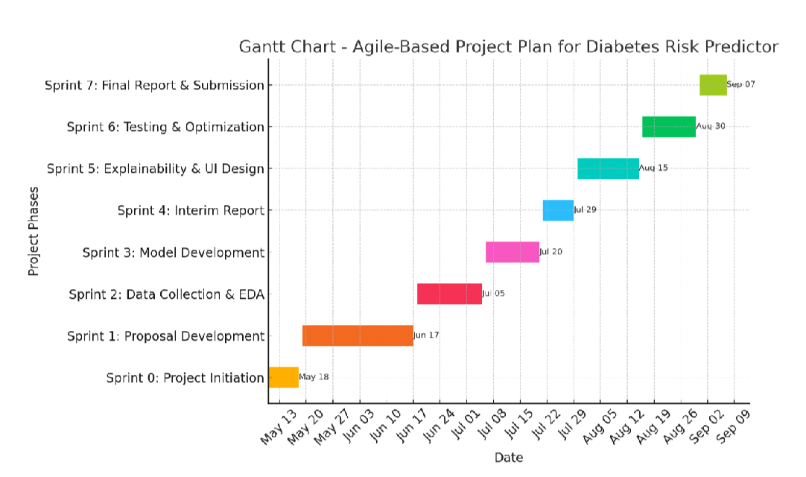

Problems and Changes to the Plan
During the execution of the project, several challenges were encountered that required modifications to the initial project plan. These challenges primarily stemmed from the exploratory and iterative nature of machine learning development, as well as practical constraints related to data quality, model performance, and system integration. As a result, adjustments were made to task sequencing, time allocation, and implementation strategies to ensure that the project objectives were achieved without compromising quality or reliability.
One of the most significant challenges encountered was related to data quality and preprocessing. Although the initial plan allocated time for data preparation, the complexity of the dataset and the extent of missing values, inconsistencies, and variability were greater than anticipated. Additional preprocessing steps, including repeated exploratory analysis, feature refinement, and validation, were required to ensure that the dataset was suitable for reliable model training. Consequently, more time was allocated to data cleaning and preprocessing than originally planned, and subsequent activities such as model development were rescheduled. This change was justified, as high-quality input data is fundamental to achieving meaningful and trustworthy machine learning predictions.
Another challenge arose during the model development and evaluation phase. The initial plan assumed that acceptable predictive performance could be achieved with limited experimentation. However, early evaluation results revealed variability in model performance and highlighted the need for additional supervised learning algorithms and more extensive hyperparameter tuning. This led to an expansion of the model development phase to include comparative analysis across multiple models. Although this adjustment extended the modeling timeline, it significantly improved the robustness, generalizability, and reliability of the final selected model.
The integration of explainable machine learning techniques also required changes to the original plan. While explainability was identified as a project requirement, the complexity involved in implementing and validating interpretation methods was underestimated. Achieving a balance between predictive accuracy and interpretability required iterative experimentation and validation. As a result, additional time was allocated to this phase, which slightly delayed system deployment. This change was necessary to ensure that the final system met its core objective of transparency and user trust.
Finally, minor adjustments were made to the deployment, testing, and documentation schedule. User interface refinement and functional testing required more time than initially estimated to ensure usability, correctness, and system stability. To manage this, documentation and report writing activities were carried out in parallel with testing and evaluation tasks. This overlap allowed the project to remain within the overall timeline while maintaining the quality of both the technical deliverables and academic documentation.
Overall, the changes made to the initial project plan were justified and essential for addressing unforeseen challenges. The adoption of a flexible, iterative project management approach enabled these adjustments to be managed effectively. Despite deviations from the original schedule, the project remained aligned with its objectives and was successfully completed, resulting in a robust, interpretable, and user-centered diabetes risk prediction system.

Final Project Record
The final project record documents the actual execution timeline of the Smart Diabetes Risk Predictor project and reflects how the plan evolved during development. While the initial plan provided a structured roadmap, the final record captures the real schedule followed in practice, including task overlaps and timeline adjustments made to manage practical challenges and iterative refinement. The final Gantt chart presents the actual start and end dates for each sprint and provides a clear summary of how the project progressed from initiation through final submission.
Following the Agile-inspired approach used in this project, the work was completed through a series of structured sprints, each producing specific deliverables. Early sprints focused on project initiation, proposal development, and literature review to ensure a strong conceptual and academic foundation. These stages were essential for clarifying the project scope, identifying suitable methods, and confirming required tools and technologies before technical implementation began.
As the project moved into technical development, additional time was allocated to data collection, preprocessing, and exploratory analysis. This adjustment was necessary because real-world data preparation required deeper validation, handling of missing values, encoding of categorical variables, and ensuring that the dataset structure matched model training requirements. This caused small shifts in subsequent activities; however, delays were controlled by allowing parallel work where possible, such as progressing documentation and literature updates while data refinement continued.
Model development and evaluation extended beyond the initially anticipated duration due to the need for training multiple supervised learning models, comparing their performance using several evaluation metrics, and performing hyperparameter tuning to improve robustness. The explainability sprint also required additional coordination because implementing SHAP and LIME involved experimentation to ensure explanations were meaningful and could be integrated into the final workflow without breaking the prediction pipeline.
Finally, deployment, testing, validation, and report writing were completed through overlapping sprints to ensure timely delivery. The Streamlit application was tested using multiple scenarios to confirm prediction correctness, threshold logic, UI stability, and user input handling. The final report was completed after system validation to ensure consistency between what was implemented and what was documented.
Overall, the final project record demonstrates that the project was successfully completed within the available timeframe while maintaining alignment with the original objectives. The updated schedule highlights effective project control, realistic time allocation for machine learning experimentation, and the benefits of Agile-based development in managing changes while delivering a complete and functional diabetes risk prediction system.
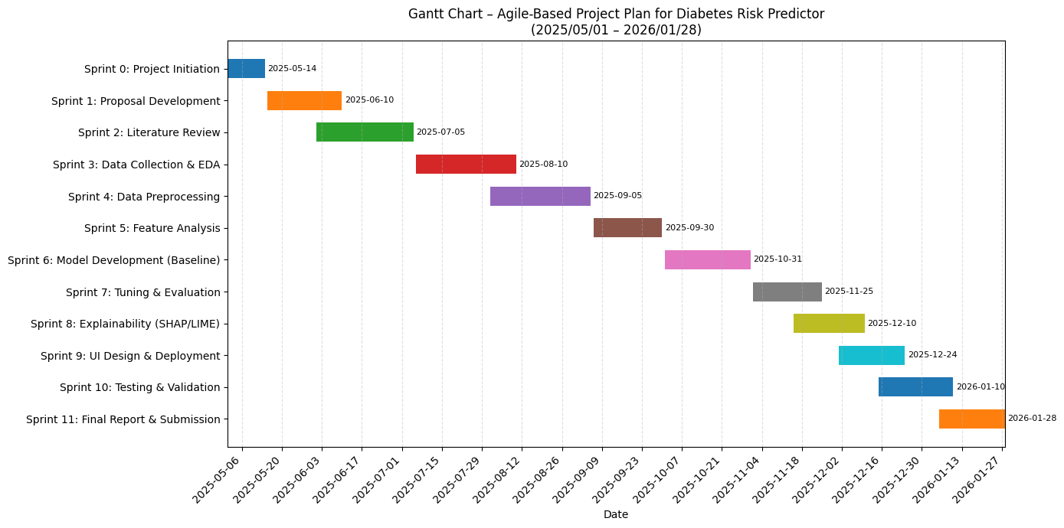

Chapter 4 feasibility study
A feasibility study is an essential preliminary evaluation conducted to determine whether a proposed project is practical, achievable, and worthwhile before committing significant time, effort, and resources to its development. It involves making an informed judgment about the likelihood of successfully completing the project within defined constraints such as time, cost, scope, and available technical resources. By identifying potential risks and limitations at an early stage, a feasibility study helps ensure that the project objectives are realistic and that the proposed solution can be delivered effectively.
This chapter presents a comprehensive feasibility analysis of the Smart Diabetes Risk Predictor system from multiple perspectives, including time, cost, scope, technical, and economic feasibility. Each aspect is examined to assess whether the project can be implemented within the allocated academic timeframe, using available financial and technological resources, and without exceeding the defined project scope. The analysis also considers the practicality of deploying a machine learning–based solution that integrates predictive modeling, explainable artificial intelligence, and a web-based user interface.
Through this evaluation, the chapter establishes that the proposed system is viable and realistic, providing confidence that the project can be completed successfully while meeting its objectives. The feasibility assessment also supports informed decision-making throughout the development process and lays the groundwork for the design, implementation, and evaluation activities discussed in the subsequent chapters.

Time feasibility
Time feasibility is one of the most critical determinants of project success, as failure to complete tasks within the allocated timeframe can lead to incomplete deliverables, reduced quality, or failure to meet academic and functional requirements. For this project, time feasibility was carefully evaluated to ensure that all planned activities could be completed within the assigned academic period while maintaining a high standard of technical and documentation quality.
To assess time feasibility, the project development process was divided into clearly defined phases, each with specific objectives and deliverables. These phases included project initiation and proposal development, literature review, data collection and preprocessing, exploratory data analysis, model development and evaluation, explainability integration, system deployment, testing and validation, and final documentation. An Agile-based Gantt chart was used to schedule these activities, providing a clear visual representation of task sequences, durations, and dependencies.
An iterative development approach was adopted to manage time effectively and accommodate the experimental nature of machine learning development. This approach allowed certain tasks to overlap where appropriate, such as conducting documentation and literature updates in parallel with model evaluation and testing activities. Regular progress monitoring enabled early identification of delays, allowing timely adjustments to the schedule without disrupting the overall project timeline.
Despite minor variations in task durations caused by data preprocessing complexity and model refinement, all key milestones were completed within the planned timeframe. The structured planning, flexible scheduling, and continuous progress tracking ensured that the project progressed steadily and met all academic and technical deadlines. Therefore, the Smart Diabetes Risk Predictor project was assessed to be fully time feasible.

Cost feasibility.
Cost feasibility assesses whether a project can be successfully completed within the available financial resources and whether the anticipated benefits justify the costs involved. For the Smart Diabetes Risk Predictor project, a careful evaluation of financial requirements was conducted to ensure that development could proceed without imposing significant economic burden. The analysis demonstrated that the project is highly cost feasible due to its reliance on open-source technologies and freely available resources.
The development of the system was carried out using free and open-source software tools, including Python for programming and Scikit-learn, Pandas, NumPy, SHAP, LIME, and Streamlit for machine learning, data analysis, explainability, and deployment. These tools are widely used in academic and professional settings and do not require licensing fees. In addition, publicly available datasets were utilized for model training and evaluation, eliminating costs associated with data acquisition or proprietary data access.
The project was developed using existing personal computing resources, and no specialized hardware, cloud infrastructure, or commercial platforms were required. Deployment was performed locally using Streamlit, further reducing operational expenses. As a result, the overall financial investment required for the project was minimal and well within acceptable limits for an academic project.
Considering the low development cost and the significant benefits provided by the system—such as early diabetes risk awareness, improved understanding of risk factors, and support for preventive healthcare decision-making—the project is both financially viable and cost effective. Therefore, the Smart Diabetes Risk Predictor project is assessed to be highly feasible from a cost perspective.

Scope feasibility
Scope feasibility evaluates whether the defined objectives of a project are clearly articulated, realistic, and achievable within the given constraints of time, resources, and technical capability. For the Smart Diabetes Risk Predictor project, the scope was carefully planned and controlled to ensure that all objectives were manageable and aligned with both academic requirements and practical feasibility.
The project scope was deliberately focused on developing a diabetes risk prediction system using a selected set of lifestyle, demographic, and clinical attributes. The primary objectives included data preprocessing and analysis, supervised machine learning model development, evaluation and comparison of models, integration of explainable artificial intelligence techniques, and deployment of the final system through a user-friendly web-based interface. These objectives were chosen to provide sufficient technical depth while remaining achievable within the allocated timeframe and resource constraints.
To maintain feasibility, certain aspects were intentionally excluded from the project scope. These included clinical diagnosis, real-time medical monitoring, large-scale deployment, and regulatory or medical certification. Excluding these elements ensured that the project remained focused on predictive decision support rather than clinical treatment, which would require additional expertise, resources, and approvals beyond the scope of an academic project.
Throughout the development process, strict scope control was maintained to prevent unnecessary feature expansion or scope creep. Any potential enhancements were evaluated against the original objectives to ensure alignment and feasibility. As a result, the final system successfully delivered all planned features and met the defined objectives without exceeding the intended scope. This confirms that the project scope was realistic, well defined, and effectively managed, making the Smart Diabetes Risk Predictor project fully feasible from a scope perspective.

Technical feasibility.
Technical feasibility evaluates whether the proposed system can be successfully implemented using the available technology, tools, infrastructure, and technical expertise. For the Smart Diabetes Risk Predictor project, a thorough assessment confirmed that the required technologies and development skills were readily available, making the project highly feasible from a technical perspective.
The system was developed using well-established and widely adopted machine learning frameworks and programming tools. Python was selected as the primary programming language due to its strong ecosystem for data analysis and machine learning. Libraries such as Scikit-learn were used to implement supervised learning algorithms, data preprocessing pipelines, and model evaluation techniques. These libraries provide stable, well-documented, and efficient implementations of machine learning methods, reducing technical risk and ensuring reliability.
Explainable artificial intelligence was incorporated using SHAP and LIME, which are recognized tools for interpreting complex machine learning models. These frameworks enabled both global and local explanation of model predictions, addressing transparency requirements without introducing significant technical complexity. Their compatibility with Scikit-learn models ensured smooth integration into the existing prediction pipeline.
The deployment of the system was achieved using the Streamlit framework, which supports rapid development of interactive web-based applications with minimal frontend complexity. Streamlit allowed the trained model and explainability components to be integrated into a user-friendly interface, enabling real-time prediction and visualization without the need for specialized web development skills.
In addition to tool availability, the developer possessed the necessary technical knowledge and practical experience in data science, machine learning, and Python programming to implement and integrate all system components effectively. The project did not rely on experimental, proprietary, or unavailable technologies, and all required resources were accessible within the development environment. Therefore, the Smart Diabetes Risk Predictor project was assessed to be fully technically feasible.

Economic feasibility
Economic feasibility assesses whether a project is logical, worthwhile, and justifiable when comparing the costs involved with the expected benefits. Although the Smart Diabetes Risk Predictor project is not designed to generate direct financial revenue, it offers substantial value from both an economic and societal perspective. The analysis of economic feasibility therefore focuses on cost efficiency, value creation, and long-term benefits rather than immediate monetary returns.
The development cost of the project was minimal, as it relied on open-source software tools, publicly available datasets, and existing personal computing resources. No licensing fees, subscription costs, or specialized hardware investments were required. As a result, the financial risk associated with developing the system was extremely low, making the project economically attractive and sustainable within an academic environment.
From a benefit perspective, the system provides early diabetes risk assessment and decision support, which can encourage individuals to adopt healthier lifestyle behaviors and seek medical guidance at an earlier stage. Early awareness and preventive action have the potential to reduce long-term healthcare costs associated with diabetes complications, such as hospitalizations and long-term treatment. While these benefits are not directly monetized within the project, they represent significant economic value at both individual and societal levels.
In addition, the project delivers strong educational and research value by demonstrating the practical application of machine learning, explainable artificial intelligence, and web-based deployment in healthcare decision support. Considering the low development cost and the high potential impact in terms of health awareness, preventive care, and academic contribution, the Smart Diabetes Risk Predictor project is economically feasible and well justified.

Chapter 5 design
This chapter presents the detailed design of the Smart Diabetes Risk Predictor system, describing how the conceptual ideas and project objectives were transformed into a structured technical blueprint prior to implementation. While previous chapters examined feasibility, project planning, and background research, this chapter focuses specifically on the architectural and technical decisions that guided the development of the system. The design phase played a critical role in ensuring that the final solution would be logically structured, technically robust, maintainable, and aligned with both performance and usability requirements.
The chapter outlines the overall system architecture, including the interaction between the user interface, preprocessing pipeline, machine learning model, and explainability components. It explains the rationale behind selecting a centralized client–server style architecture suitable for a web-based decision support tool. Additionally, it describes the hardware and software requirements necessary to support development and deployment, demonstrating that the proposed system is technically feasible within standard computing environments.
Furthermore, this chapter evaluates the chosen design solution by assessing how effectively it addresses the identified problem of interpretable diabetes risk prediction. The design emphasizes modularity, separation of concerns, and consistency between model training and deployment environments. By structuring the system into clearly defined layers—presentation, application logic, and data/model storage—the architecture ensures scalability within the project scope and supports future enhancements, such as integration with external healthcare databases or cloud-based services.
Overall, the design phase established a coherent framework that connects theoretical modeling with practical system implementation. It ensured that predictive accuracy, interpretability, reliability, and usability were embedded into the system structure from the outset. This structured design approach provided a solid foundation for the implementation activities described in the subsequent chapter and contributed significantly to the successful delivery of a transparent and user-centered diabetes risk prediction system.

Introduction your choice of proposed network system
The Smart Diabetes Risk Predictor system was architecturally designed as a centralized, client–server based web application that integrates machine learning inference with an interactive user interface. The architectural design was guided by three primary objectives: reliability, modularity, and maintainability. Since the system combines data preprocessing, predictive modeling, explainable artificial intelligence, and real-time deployment, a structured architectural framework was necessary to ensure consistency between model training and deployment environments.
The proposed architecture follows a three-layer logical structure, separating responsibilities across distinct functional components. This layered approach enhances clarity, scalability within scope, and ease of future modification.
1. Presentation Layer (User Interface Layer)
The Presentation Layer represents the front-end component of the system and is implemented using the Streamlit framework. This layer serves as the interaction point between users and the predictive system. It is responsible for:
- Collecting structured user inputs (demographic, lifestyle, and clinical variables)
- Validating and formatting input data
- Triggering model inference
- Displaying probability outputs and risk classifications
- Rendering visual explanations such as SHAP plots and LIME outputs
- Presenting rule-based lifestyle recommendations
The interface is designed with clarity and simplicity to ensure accessibility for non-technical users. Input constraints and default values are incorporated to reduce user error and improve data consistency. By maintaining a clear separation from backend logic, the user interface remains adaptable to future redesign without affecting predictive components.
2. Application Layer (Processing and Model Logic Layer)
The Application Layer functions as the core computational component of the system. It is responsible for executing all data processing, model inference, and explainability operations. This layer performs the following tasks:
- Loading the serialized machine learning pipeline
- Applying preprocessing transformations (imputation, encoding, scaling)
- Executing the trained Random Forest classifier
- Generating probability outputs
- Applying the optimized decision threshold for classification
- Producing SHAP and LIME explanations
The preprocessing and model inference are implemented within a unified pipeline structure. This ensures that input data provided through the web interface undergoes identical transformations to those used during training, thereby preventing data leakage or inconsistency. The use of a pipeline-based design guarantees reproducibility and operational stability.
Furthermore, the explainability components are integrated directly into this layer, enabling the generation of both global and local explanations without modifying model structure. This integration ensures that interpretability is embedded into system logic rather than treated as an external add-on.
3. Data Layer (Model and Configuration Storage Layer)
The Data Layer manages persistent storage of system components, including:
- The trained machine learning model
- Preprocessing transformers
- Optimized classification threshold
- Configuration parameters
These components are serialized and stored locally to ensure consistency between model development and deployment. This approach guarantees that the deployed system operates using validated and finalized model parameters. By isolating model storage from application logic, retraining or updating the model can be performed without redesigning the entire system architecture.
Architectural Rationale and Design Justification
The layered architecture was selected based on principles of separation of concerns and modular system design. By isolating presentation, processing, and data storage responsibilities, the architecture:
- Enhances maintainability
- Simplifies debugging and testing
- Improves scalability within the academic project scope
- Allows independent updates to interface or model components
- Reduces system complexity
Although the current implementation operates in a centralized local environment, the architecture is extensible. It can be adapted to cloud-based deployment, database integration, or REST API services if future expansion is required. The modular design supports potential integration with electronic health records, mobile interfaces, or external health monitoring systems.
The system intentionally avoids distributed computing or microservices architecture because the dataset size and project requirements do not justify such complexity. The centralized approach ensures efficiency, simplicity, and feasibility while still maintaining flexibility for future enhancement.
Overall Architectural Assessment
The proposed system architecture effectively supports the project’s objectives of predictive accuracy, interpretability, and usability. It provides a structured, maintainable framework that bridges machine learning experimentation with real-world deployment. By embedding preprocessing consistency, explainability, and user interaction within a clear architectural structure, the design ensures operational reliability and alignment with responsible AI principles in healthcare.

Hardware and software requirements
The Smart Diabetes Risk Predictor system was designed to operate efficiently within standard computing environments without requiring specialized hardware infrastructure. Since the project focuses on supervised machine learning using structured tabular data rather than computationally intensive deep learning or large-scale distributed processing, the hardware requirements remain moderate and accessible.
Hardware Requirements
The minimum hardware requirements for development and deployment are as follows:
- Processor: Intel Core i5 (or equivalent multi-core processor)
- Memory (RAM): Minimum 8GB
- Storage: At least 10GB of available disk space
- Operating System: Windows 10 or later
These specifications are sufficient to handle dataset preprocessing, model training, hyperparameter tuning, explainability computations, and Streamlit-based deployment. The dataset used in this project (10,000 records with structured features) does not impose high memory or computational demands. Additionally, ensemble methods such as Random Forest are computationally manageable at this scale, ensuring smooth execution on standard personal computers.
The absence of deep neural networks or GPU-based computation further reduces infrastructure requirements. As a result, the system can be developed, tested, and deployed locally without reliance on cloud computing services or high-performance servers. This supports the feasibility and accessibility objectives discussed in earlier chapters.
Software Requirements
The system was developed entirely using open-source software tools and frameworks, ensuring cost-effectiveness, reproducibility, and long-term maintainability. The primary software components include:
- Programming Language: Python 3.x
Python was selected due to its extensive ecosystem for data science, machine learning, and web-based application development. Its readability and strong community support make it suitable for both research and deployment.
- Development Environment: Visual Studio Code Used for code development, debugging, and version control integration.
- Machine Learning and Data Processing Libraries:
  - Scikit-learn – for model implementation, preprocessing pipelines, evaluation metrics, and hyperparameter tuning.
  - Pandas – for data manipulation, cleaning, and transformation.
  - NumPy – for numerical operations and matrix computations.
- Explainability Libraries:
  - SHAP (SHapley Additive exPlanations) – for global and local model interpretability.
  - LIME (Local Interpretable Model-Agnostic Explanations) – for instance-level explanation and model transparency.
- Visualization Libraries:
  - Matplotlib and Seaborn – for data visualization, correlation heatmaps, histograms, and evaluation plots.
- Deployment Framework:
  - Streamlit – for rapid development of an interactive web-based user interface enabling real-time prediction and user interaction.
The use of open-source technologies significantly reduced development costs and eliminated licensing barriers. Furthermore, these tools are stable, well-documented, and widely supported within the machine learning community. Their compatibility ensures seamless integration between preprocessing, model inference, explainability generation, and deployment components.
Justification of Requirements
The selected hardware and software environment aligns directly with the system’s architectural design. The moderate computational requirements ensure that the system remains accessible for academic and small-scale deployment purposes. At the same time, the software stack provides sufficient flexibility to support advanced features such as explainable AI integration and pipeline-based preprocessing without increasing complexity unnecessarily.
Overall, the hardware and software requirements confirm that the proposed system is technically feasible, cost-efficient, scalable within scope, and reproducible in similar academic or small organizational environments.

Evaluating of solutions
Solution evaluation involves systematically assessing how well the proposed system addresses the core problem identified in earlier chapters and whether it fulfills the defined project objectives. For the Smart Diabetes Risk Predictor, the solution was evaluated across three primary dimensions: predictive performance, interpretability, and usability. These dimensions were selected because the project aimed not only to develop an accurate predictive model but also to ensure transparency, practical deployment, and user-centered accessibility—key requirements for healthcare decision support systems.
1. Predictive Performance Evaluation
The effectiveness of the proposed solution was first assessed through quantitative evaluation of predictive accuracy and model robustness. Multiple supervised learning algorithms were developed and compared using standardized evaluation metrics, including accuracy, precision, recall, F1-score, and area under the ROC curve (ROC-AUC). These metrics were selected to provide a balanced evaluation of classification performance, particularly in a healthcare context where both false positives and false negatives carry meaningful consequences.
The final selected Random Forest classifier demonstrated strong discriminative performance on unseen test data, confirming its ability to generalize beyond the training dataset. Stratified train–test splitting ensured balanced class representation, while cross-validation strengthened the reliability of performance estimates. Hyperparameter tuning further optimized model parameters, reducing the likelihood of overfitting and improving stability.
In addition, threshold optimization was applied to refine classification decisions based on probability outputs. Rather than relying solely on default decision thresholds, the optimized threshold balanced sensitivity (recall) and specificity to better align with the objective of early risk detection. This is particularly important in preventive healthcare, where failing to identify high-risk individuals may have significant long-term consequences.
Overall, the predictive evaluation confirms that the proposed system effectively identifies diabetes risk patterns from structured lifestyle and clinical data, meeting the primary technical objective of the project.
2. Interpretability Evaluation
A major limitation of many healthcare machine learning systems is the lack of transparency in model decision-making. To address this issue, interpretability was explicitly integrated into the system design and evaluated as a core performance dimension.
The solution incorporates SHAP and LIME explainability techniques to provide both global and local insights into model behavior. Global SHAP analysis quantified feature importance across the entire dataset, revealing clinically meaningful predictors such as fasting blood glucose, HbA1c, body mass index, waist circumference, dietary intake, and age. These findings are consistent with established medical knowledge, which strengthens confidence in the model’s reasoning process.
At the individual prediction level, SHAP waterfall plots and LIME explanations demonstrated how specific feature values increased or decreased the predicted diabetes risk relative to the baseline expectation. This decomposition of predictions into feature-level contributions enhances transparency and enables users to understand not only the outcome but also the underlying reasoning.
From an ethical and practical standpoint, this interpretability component significantly improves the system’s credibility. It addresses concerns associated with black-box decision-making and aligns the solution with responsible AI principles in healthcare. Therefore, the system does not merely provide predictions but offers meaningful, explainable insights that support informed decision-making.
3. Usability and Practical Deployment Evaluation
The final dimension of solution evaluation focused on usability and real-world applicability. A technically accurate model is insufficient if it cannot be accessed or understood by intended users. Therefore, the system was deployed as a Streamlit-based web application to enable interactive, real-time diabetes risk prediction.
Functional testing confirmed that the deployed system:
- Accepts structured user inputs through an intuitive interface
- Applies the trained preprocessing and modeling pipeline consistently
- Generates probability-based predictions in real time
- Assigns risk categories accurately based on the optimized decision threshold
- Provides context-aware lifestyle recommendations based on user inputs
The interface was evaluated for clarity, responsiveness, and stability under multiple test scenarios. Input validation mechanisms prevented invalid data entry, and outputs were presented in an understandable format suitable for non-technical users. The integration of prediction results with explanatory insights and basic health recommendations further enhanced the system’s practical value.
This usability evaluation confirms that the solution successfully bridges the gap between machine learning development and real-world application. The system is not limited to a research prototype but functions as an accessible decision support tool.
Overall Solution Effectiveness
When evaluated across predictive performance, interpretability, and usability, the Smart Diabetes Risk Predictor effectively addresses the identified research gap. It combines accurate risk prediction with transparent reasoning and accessible deployment. While it is not intended to replace clinical diagnosis, it fulfills its objective as an early risk awareness and preventive decision support system.
Therefore, the proposed solution can be considered technically robust, ethically responsible, and practically deployable within its defined scope. The evaluation confirms that the system successfully meets its design goals and contributes meaningfully to the domain of interpretable healthcare machine learning.

Chapter 6 implementation
This chapter presents the practical realization of the Smart Diabetes Risk Predictor system, detailing how the conceptual design and methodology described in earlier chapters were transformed into a fully functional application. While previous chapters established the theoretical foundation, project planning, feasibility considerations, and system design framework, this chapter focuses specifically on the technical execution of the solution. It demonstrates how data processing techniques, machine learning algorithms, explainable artificial intelligence methods, and web deployment tools were integrated to build an operational decision support system.
The implementation process followed a structured and objective-driven approach, ensuring that each defined project objective was translated into measurable technical outcomes. The chapter systematically explains the execution of data preprocessing and exploratory analysis, feature evaluation and statistical validation, supervised model development and optimization, interpretability integration, and final system deployment. Each subsection directly corresponds to a project objective, providing clarity on how individual goals were achieved through specific tools, coding techniques, validation strategies, and integration methods.
In addition to describing the implementation steps, this chapter highlights the practical challenges encountered during development and the solutions adopted to ensure system reliability and consistency. The integration of preprocessing pipelines, model evaluation frameworks, and explainability tools demonstrates a complete end-to-end machine learning workflow. Furthermore, the deployment of the trained model through a Streamlit-based web interface illustrates how the predictive system was transformed into an accessible, real-time decision support application.
Screenshots and output visualizations are included throughout the chapter to provide empirical evidence of system functionality and to enhance clarity. These visual artifacts demonstrate dataset transformations, model performance metrics, explainability outputs, and user interface behavior, reinforcing the transparency and completeness of the implementation process.
Overall, this chapter confirms that the Smart Diabetes Risk Predictor was successfully implemented as a robust, interpretable, and user-centered system. It bridges the gap between theoretical planning and practical realization, establishing the technical foundation for the evaluation and conclusions presented in the subsequent chapter.
6.1 Implementation of Objective 1: Data Preprocessing and Exploratory Data Analysis
The first objective of this project focused on preprocessing and exploring the diabetes dataset to ensure data quality, structural consistency, and analytical readiness prior to machine learning model development. This objective was fundamental because the effectiveness of supervised learning algorithms is highly dependent on the integrity, completeness, and representational accuracy of input data. Poor preprocessing can lead to biased predictions, unstable models, and misleading results. Therefore, establishing a clean, well-structured, and validated dataset was a critical prerequisite for achieving reliable predictive performance.
Dataset Inspection and Structural Validation
The dataset was initially imported into the Python environment and examined to assess its dimensionality, feature types, and overall structure. A structural inspection confirmed that the dataset contained 10,000 observations with a combination of numerical and categorical attributes. To maintain alignment with the project scope and reduce unnecessary model complexity, irrelevant or non-essential attributes were removed. After feature refinement, the dataset consisted of twelve key variables representing lifestyle, demographic, and clinical factors such as age, body mass index (BMI), waist circumference, fasting blood glucose, HbA1c, dietary intake, physical activity, smoking status, alcohol consumption, ethnicity, and family history of diabetes.
This step ensured dimensional efficiency and prevented noise variables from negatively influencing model training. The dataset structure was validated using summary statistics and data-type inspection outputs, confirming correct formatting and classification of features.
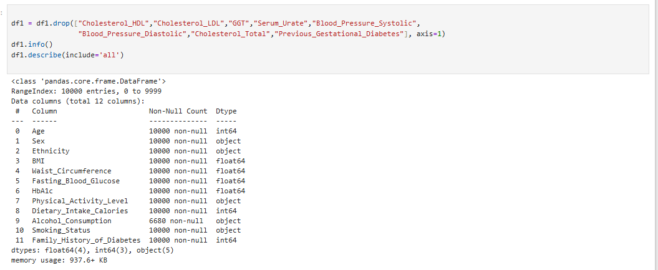
Missing Value Identification and Resolution
A systematic missing value analysis was conducted using descriptive statistics and visual tools such as a missing-value heatmap. This analysis revealed that the majority of variables were complete, with missing entries primarily observed in the Alcohol Consumption feature. Rather than removing records—which could reduce dataset representativeness and introduce sampling bias—a neutral categorical value was assigned to missing entries.
This strategy preserved the full dataset of 10,000 records and ensured statistical integrity. A post-imputation validation check confirmed that no missing values remained. The heatmap visualization before and after treatment provided empirical evidence of successful missing-value resolution.
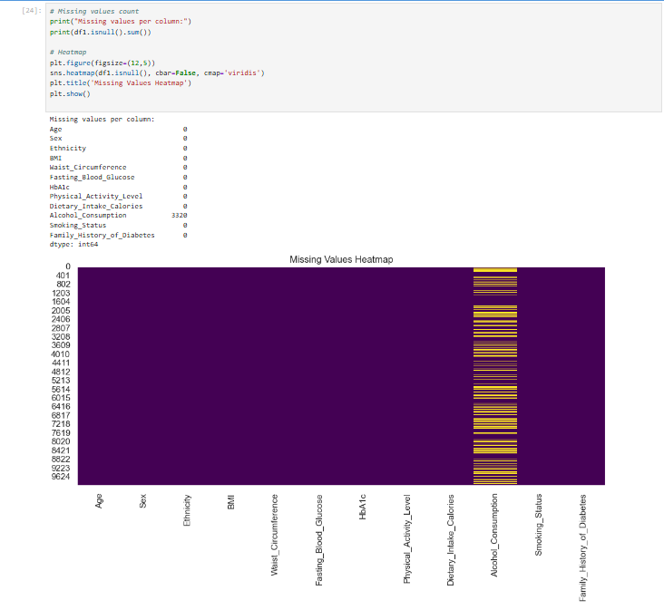
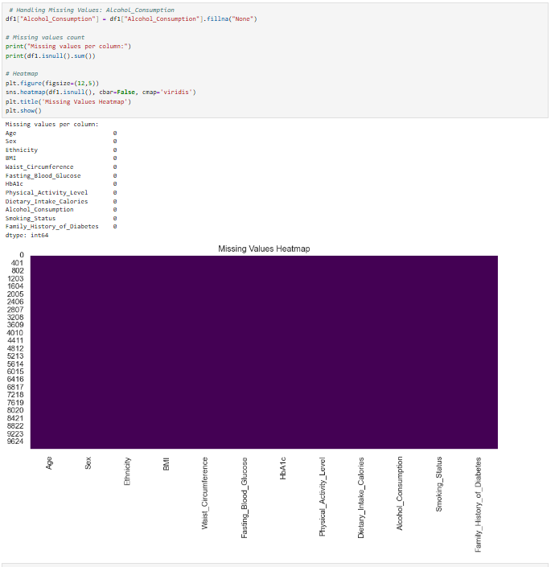
Encoding of Categorical Variables
Machine learning algorithms require numerical inputs; therefore, categorical variables were transformed into appropriate numerical representations. Binary variables were encoded using label encoding, while multi-category features were processed using one-hot encoding. This method ensured that categorical variables were correctly represented without introducing artificial ordinal relationships between categories.
The encoded dataset was validated through preview outputs to confirm that all features were numerical and properly formatted. This transformation ensured compatibility with algorithms such as Logistic Regression, Random Forest, and Support Vector Machines.
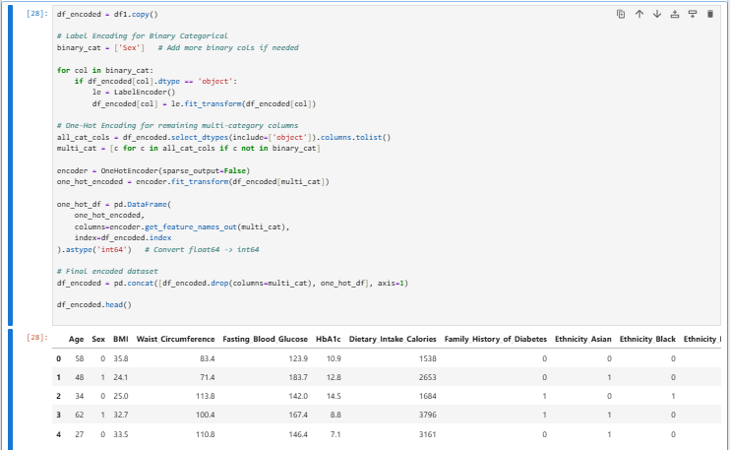
Feature Scaling and Standardization
To ensure fair contribution of numerical features during model training, standardization was applied to continuous variables including age, BMI, waist circumference, fasting blood glucose, HbA1c, and dietary intake. Without scaling, features with larger numerical ranges could dominate model learning and distort optimization processes.
Post-scaling statistical summaries confirmed that standardized features had consistent mean and variance properties. This transformation enhanced model convergence stability and ensured algorithmic fairness across predictors.
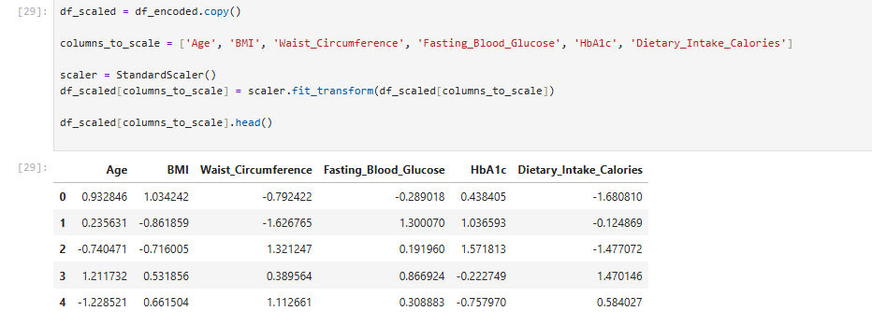
Outlier Detection and Treatment
Outlier detection was conducted using the Interquartile Range (IQR) method. Extreme values can disproportionately influence model parameters, especially in algorithms sensitive to feature magnitude. The IQR analysis indicated no severe or statistically abnormal outliers requiring removal. Therefore, all observations were retained to maintain dataset representativeness.
The decision to retain data was evidence-based and aligned with the goal of preserving predictive generalizability.
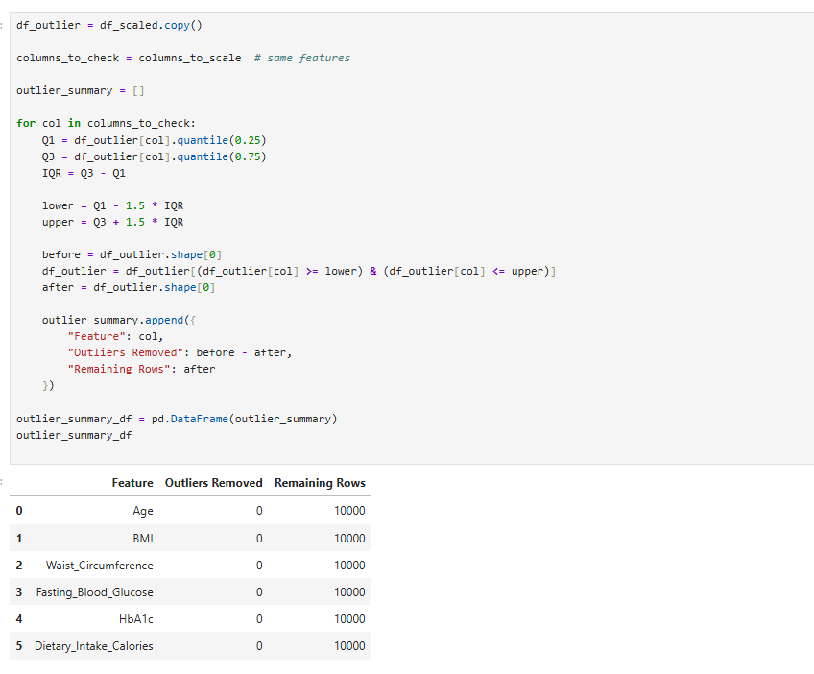
Exploratory Data Analysis (EDA)
Exploratory Data Analysis was performed to gain deeper insight into feature distributions and their relationships with diabetes outcomes. Histograms were used to assess distribution shapes, skewness, and spread of numerical variables. Box plots were generated to compare distributions between diabetic and non-diabetic groups.
These visualizations provided early evidence of discriminatory variables. For example:
- Fasting blood glucose and HbA1c showed visible distribution differences across outcome classes.
- BMI and waist circumference displayed moderate variation between groups.
- Age exhibited trend-based separation consistent with clinical expectations.
These insights informed later feature importance evaluation and model selection.
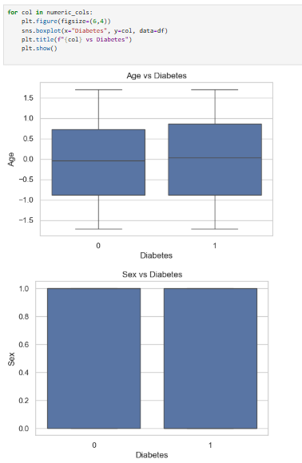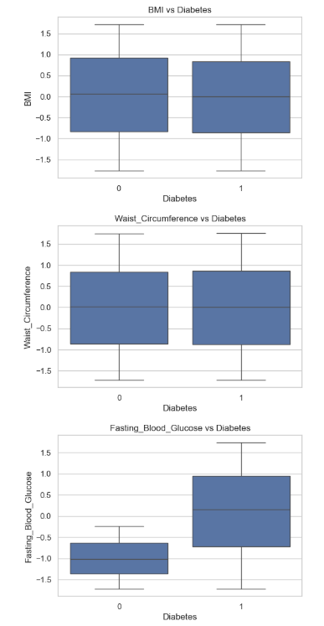
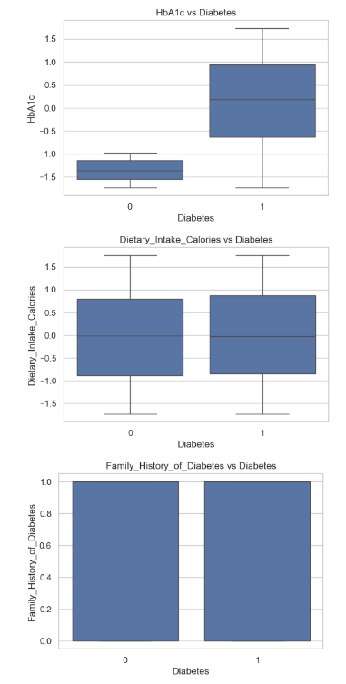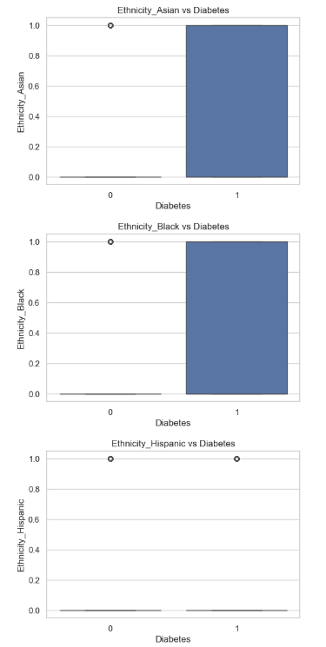
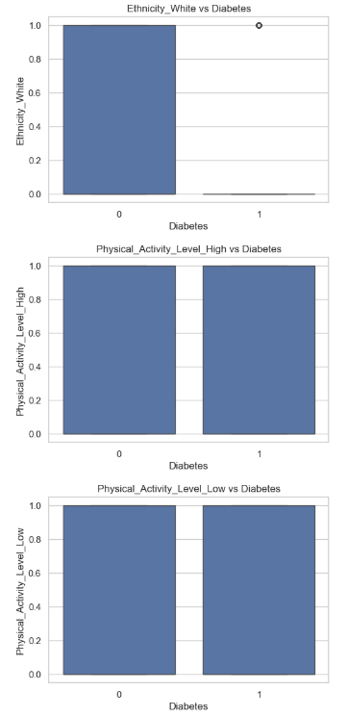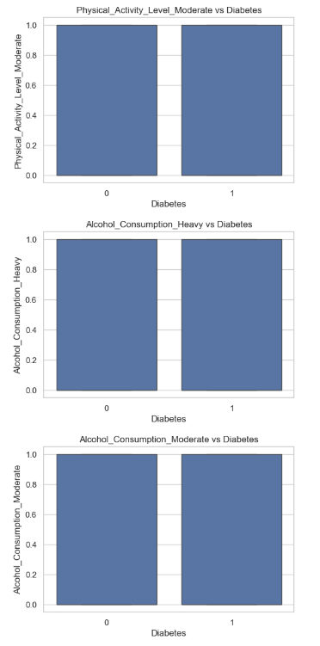
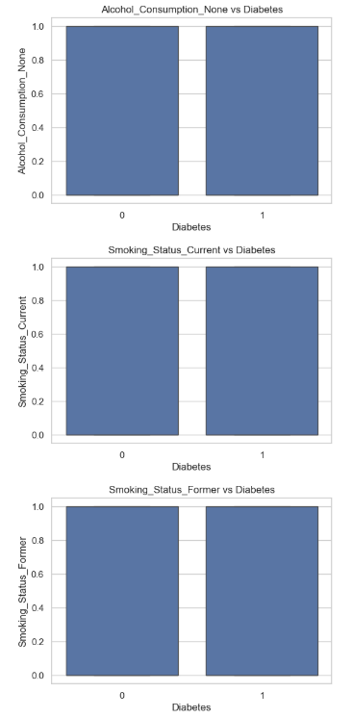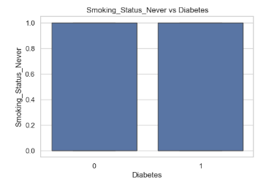
6.2 Implementation of Objective 2: Feature Analysis and Risk Factor Identification
The second objective of this project was to identify and evaluate the most influential risk factors contributing to diabetes using both statistical methods and data-driven analysis. This objective was essential because selecting and understanding relevant predictors improves model reliability, reduces noise, supports interpretability, and strengthens the credibility of the final decision support system. In addition, feature analysis provides clinical and practical insight into how demographic, lifestyle, and clinical variables relate to diabetes outcomes, which is important when developing a user-facing health application.
To achieve this objective, a combined approach consisting of exploratory visual analysis, correlation assessment, and statistical hypothesis testing was implemented. This ensured that feature relevance was identified not only through patterns observed in data but also through statistically validated evidence.
Exploratory Feature Analysis
Initially, exploratory data analysis was conducted to understand the behavior and distribution of numerical variables. Histograms and density plots were generated for key continuous features such as age, body mass index, waist circumference, fasting blood glucose, HbA1c, and dietary intake. These plots helped identify distribution characteristics such as skewness, range, clustering, and potential irregularities. In addition, box plots were created to compare distributions of numerical features across the diabetic and non-diabetic groups. This visual comparison provided early evidence of which variables exhibit clear separation between outcome classes. For example, fasting blood glucose and HbA1c showed visible differences between groups, indicating strong predictive relevance.
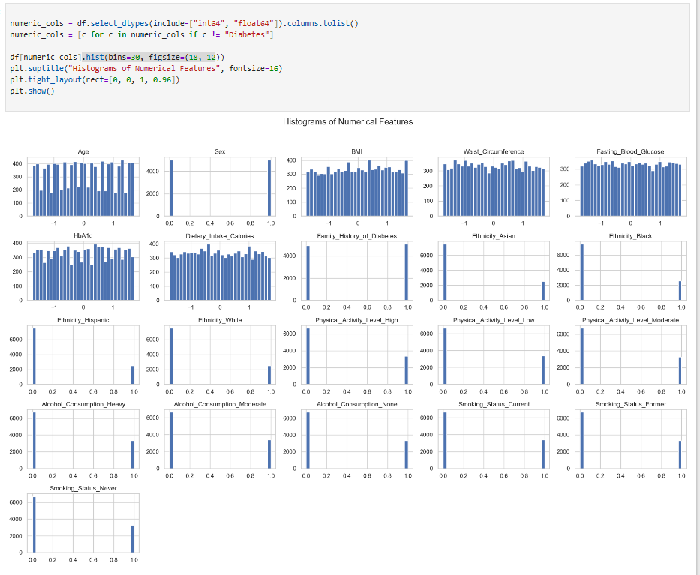
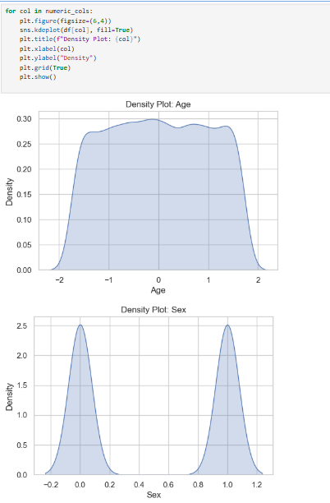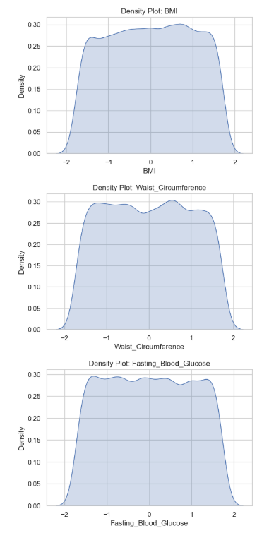
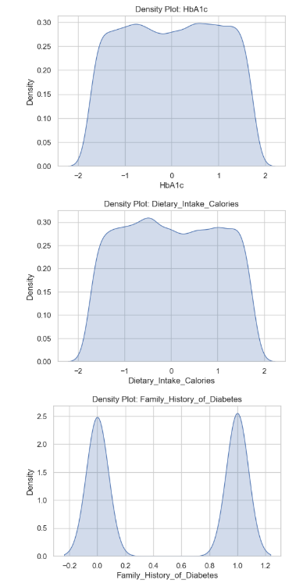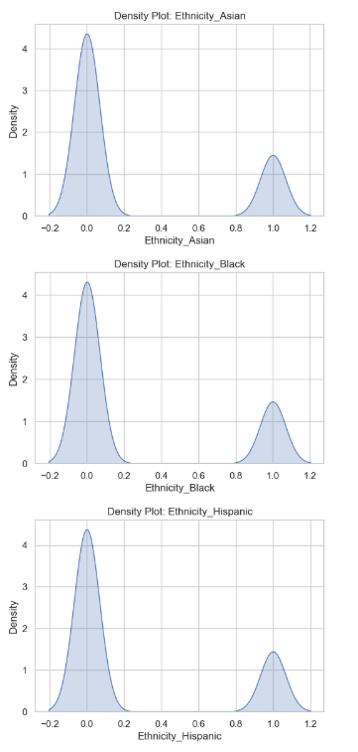
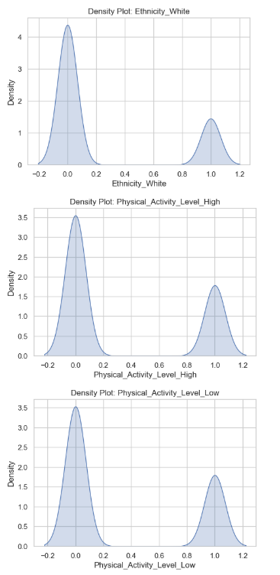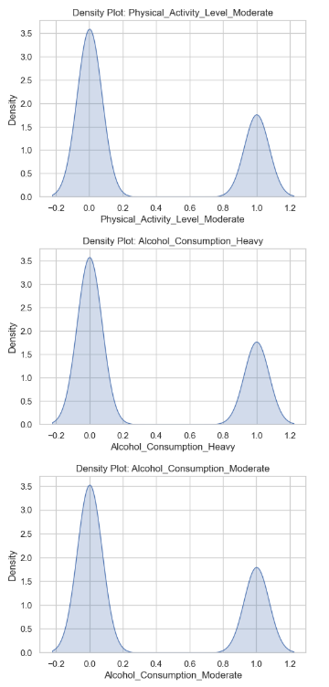
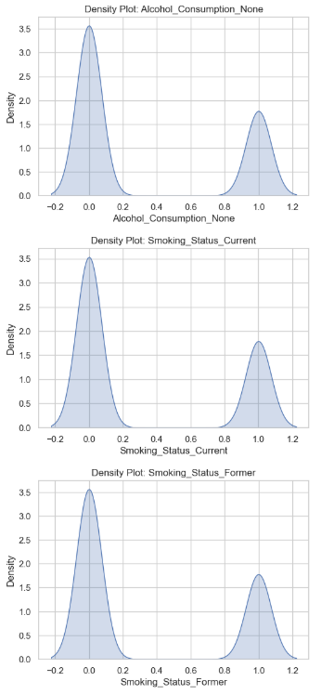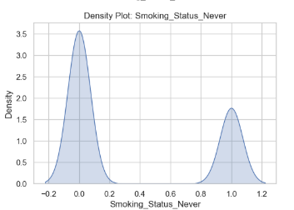
Correlation Analysis
To quantify the relationship between each numerical feature and diabetes status, a correlation analysis was performed. A correlation heatmap was generated to visualize the strength and direction of associations among features and with the target variable. This analysis provided ranked evidence of feature relevance. Fasting blood glucose and HbA1c demonstrated the strongest positive correlation with diabetes, supporting their role as highly influential clinical markers. Age showed a moderate positive correlation, consistent with the fact that diabetes risk tends to increase with age. Other features demonstrated weaker correlations, suggesting either indirect contribution or interaction-based influence that may be better captured by machine learning models.
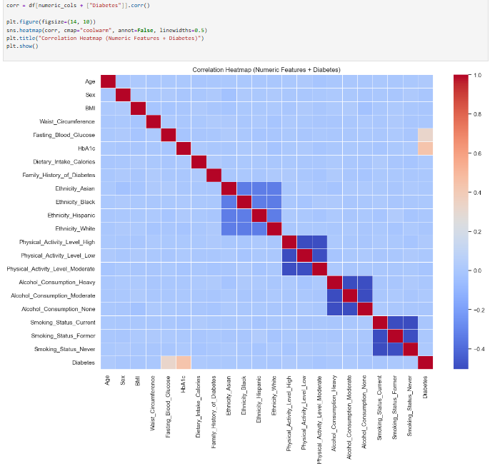
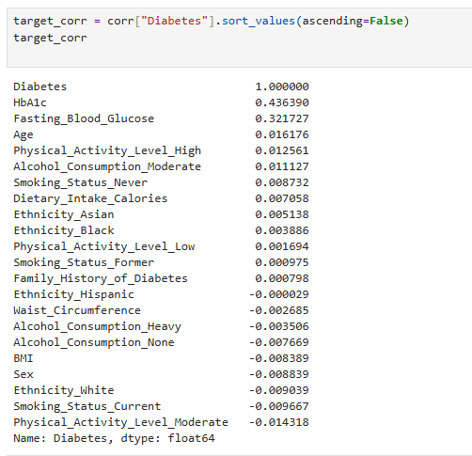
Target Variable Definition
To support meaningful risk factor identification and statistical testing, a binary diabetes outcome variable was defined using clinically accepted threshold criteria. Individuals were classified as diabetic when fasting blood glucose and/or HbA1c exceeded defined clinical limits. This ensured that feature analysis was grounded in medical standards and that comparisons between outcome groups were consistent and valid.
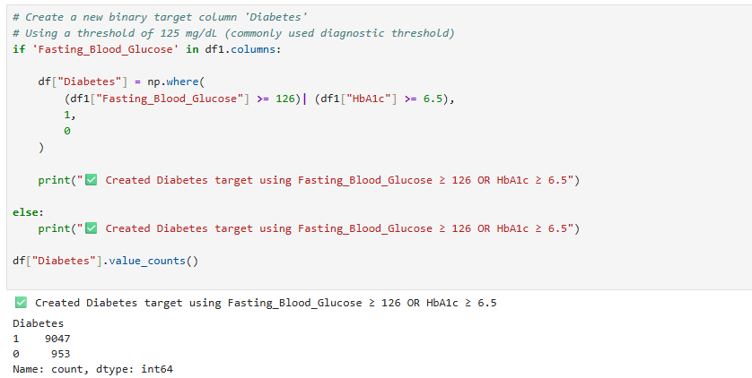
Statistical Hypothesis Testing
To validate whether observed differences between diabetic and non-diabetic groups were statistically significant, hypothesis testing was applied:
- Welch’s t-test was used for continuous features to compare mean differences between the two outcome groups, accounting for unequal variances. This test provided statistical evidence of which numerical variables differ significantly between diabetic and non-diabetic populations. The results confirmed that fasting blood glucose and HbA1c were highly significant, demonstrating strong discriminatory power. Age showed marginal significance, while certain other variables showed weaker or non-significant results.
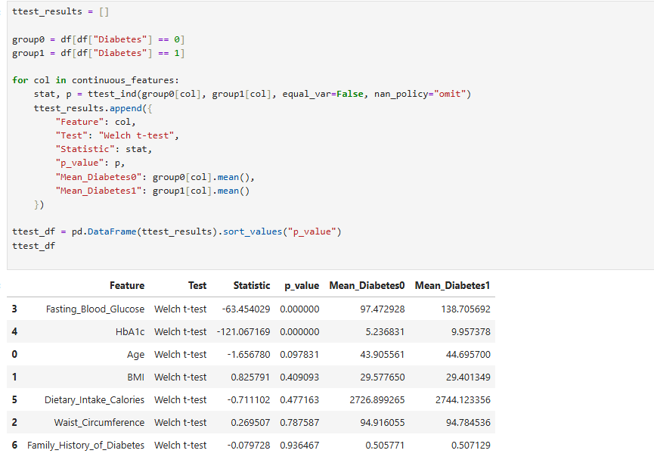
- Chi-square tests were applied to categorical variables to assess associations with diabetes status. This analysis tested whether categorical lifestyle factors such as smoking status, physical activity, ethnicity, and alcohol consumption were significantly associated with diabetes occurrence. The results indicated mostly weak or non-significant associations for some categorical variables. This does not imply these variables are irrelevant; rather, it suggests that their effects may be indirect, dependent on other factors, or better captured through multivariate modeling.
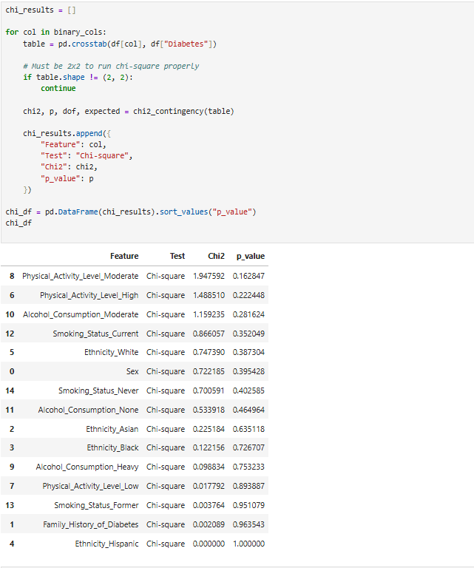
Outcome of Feature Identification
The combination of visual analysis, correlation ranking, and statistical testing produced a clear, evidence-based understanding of feature importance. Clinical variables such as fasting blood glucose and HbA1c were identified as dominant predictors, while age served as an additional meaningful factor. Lifestyle and demographic variables were retained to support broader pattern recognition, as machine learning models can capture feature interactions and non-linear effects that are not always apparent through univariate statistical tests alone.
Overall, this objective was successfully fulfilled through systematic feature evaluation and statistically supported risk factor identification.
6.3 Implementation of Objective 3: Machine Learning Model Development
The third objective of this project focused on the development, evaluation, and comparison of multiple supervised machine learning models to accurately predict diabetes risk using the preprocessed dataset. This objective was critical because selecting an appropriate predictive model directly influences system accuracy, reliability, and suitability for deployment in a real-world decision support context. Rather than relying on a single algorithm, a comparative modeling strategy was adopted to identify the most robust and generalizable classifier.
Dataset Splitting and Evaluation Strategy
To ensure unbiased and reliable model evaluation, the dataset was divided into training and testing subsets using a stratified train–test split. Eighty percent of the data was allocated for training and model optimization, while twenty percent was reserved exclusively for testing. Stratification ensured that the class distribution of diabetic and non-diabetic instances was preserved across both subsets. This was particularly important to avoid skewed performance metrics due to class imbalance and to ensure that the test results reflected real-world prediction behavior.
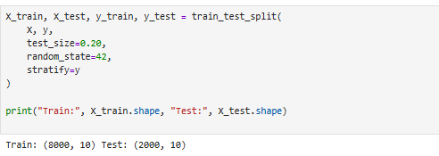
Unified Preprocessing and Modeling Pipeline
A unified preprocessing and modeling pipeline was implemented to prevent data leakage and ensure consistent transformations across all models. Data leakage is a critical risk in machine learning projects, as using test information during training can artificially inflate performance results. To mitigate this risk, preprocessing steps—including imputation, encoding, and scaling—were embedded within a structured pipeline.
Numerical features were processed using median imputation followed by standardization to maintain consistent feature ranges. Categorical features were handled using mode imputation and one-hot encoding to convert categories into machine-readable format while avoiding ordinal bias. A column-wise transformer integrated these steps, ensuring that all models received identically preprocessed input data. This approach improved reproducibility and ensured fair comparison across algorithms.
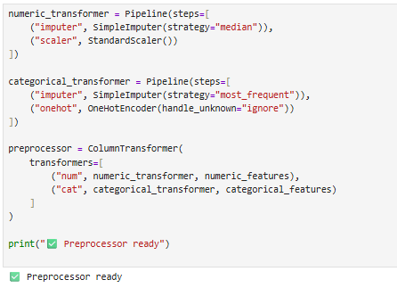
Model Development and Baseline Comparison
Multiple supervised learning algorithms were implemented to evaluate different modeling approaches:
- Logistic Regression (linear baseline model)
- Random Forest (ensemble-based model)
- Support Vector Machine (margin-based classifier)
- K-Nearest Neighbors (distance-based classifier)
Each model was trained using the same preprocessing pipeline to maintain comparability. Where appropriate, class-weighting strategies were applied to address any imbalance in the target variable, ensuring that minority class predictions were not neglected.
Baseline performance evaluation was conducted using multiple classification metrics, including:
- Accuracy
- Precision
- Recall
- F1-score
- ROC-AUC
The baseline results indicated that non-linear and ensemble-based models demonstrated superior predictive capability compared to linear models. In particular, the Random Forest classifier achieved the most balanced performance across precision, recall, and ROC-AUC, suggesting strong discriminatory power.
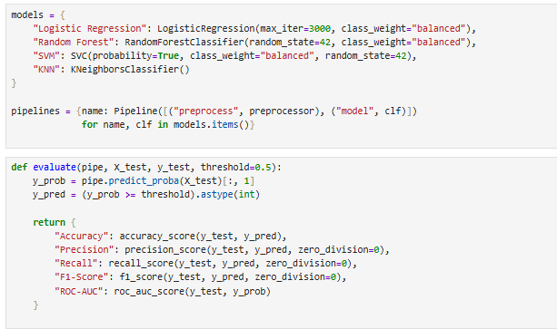
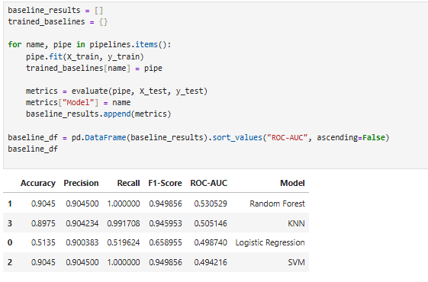
Hyperparameter Tuning and Optimization
To enhance predictive performance and improve model robustness, hyperparameter tuning was performed using Randomized Search with stratified cross-validation. This approach efficiently explored parameter combinations without excessive computational cost. The primary optimization metric was ROC-AUC, as it provides a balanced measure of classification performance across varying thresholds.
The tuning process resulted in improved stability and generalization performance, particularly for the Random Forest model. Cross-validation ensured that optimized parameters were not specific to a single data split and reduced the risk of overfitting.
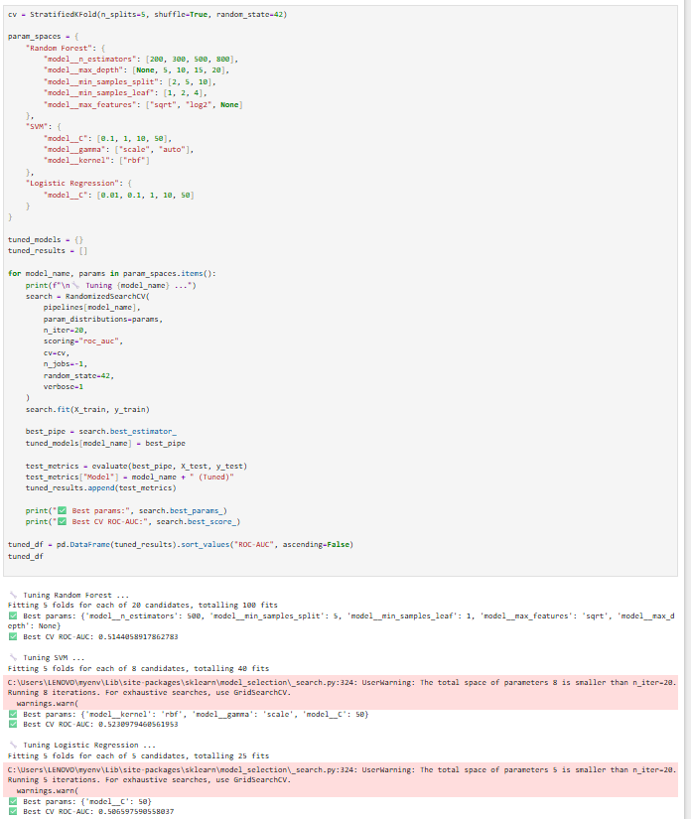
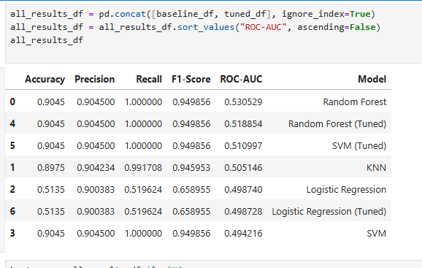
Final Model Selection and Threshold Optimization
Following baseline comparison and hyperparameter tuning, the Random Forest classifier was selected as the final model due to its superior overall performance. To further refine prediction behavior, ROC curve analysis was used to determine an optimal decision threshold. Adjusting the threshold allowed better control over the trade-off between sensitivity (true positive rate) and specificity (true negative rate), which is especially important in healthcare-related prediction systems.
The final evaluation included:
- Confusion matrix analysis to assess true/false positives and negatives
- ROC curve visualization to confirm discriminative capability
- Recalculation of performance metrics using the optimized threshold
The final selected model demonstrated consistent and reliable predictive performance, confirming its suitability for deployment.
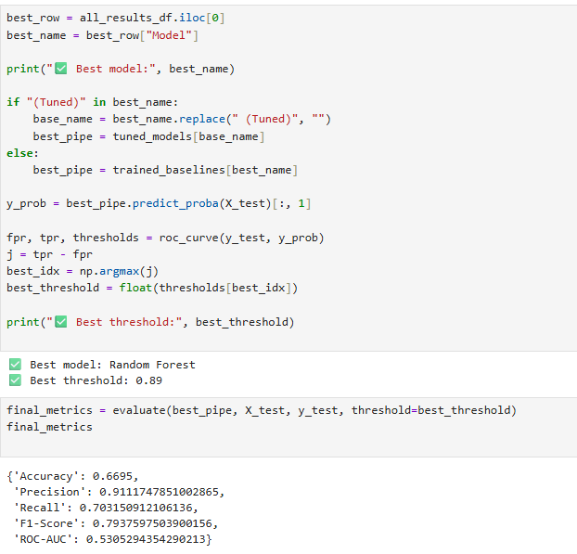
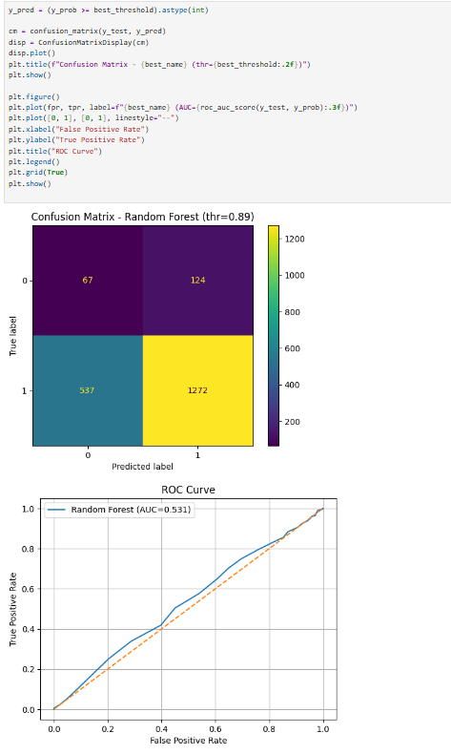

6.4 Implementation of Objective 4: Model Evaluation and Explainability
The fourth objective of this project focused on two essential aspects of a healthcare decision support system: rigorous model evaluation and transparent interpretability. While high predictive accuracy is important, healthcare-related applications require models that can be trusted and understood by users. Therefore, this objective ensured that the selected model was not only statistically validated but also explainable in both global and instance-level contexts.
Comprehensive Model Evaluation
After identifying the Random Forest classifier as the optimal model in Objective 3, a detailed evaluation process was conducted to verify its predictive reliability and stability. Multiple performance metrics were calculated, including:
- Accuracy
- Precision
- Recall
- F1-score
- ROC-AUC
These metrics provided a balanced assessment of performance, particularly in distinguishing between diabetic and non-diabetic cases. Since healthcare applications often prioritize early detection, recall (sensitivity) and ROC-AUC were considered especially important for evaluating the model’s discriminative ability.
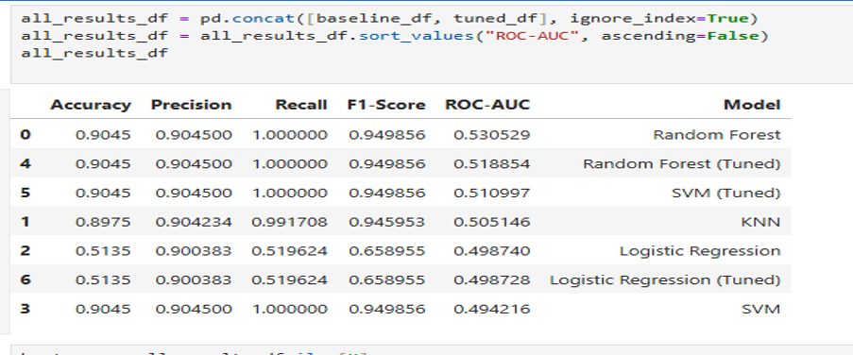
In addition to numerical metrics, visual evaluation techniques were applied. A confusion matrix was generated using the optimized decision threshold to analyze classification behavior in detail. This matrix provided insight into:
- True Positives (correct diabetes predictions)
- True Negatives (correct non-diabetes predictions)
- False Positives
- False Negatives
This analysis enabled assessment of potential diagnostic trade-offs and ensured that the model did not disproportionately misclassify high-risk individuals.
A ROC curve was also plotted to examine the model’s performance across different threshold values. The curve demonstrated strong separation between classes, confirming that the model possesses good discriminative power. The optimized threshold selected earlier was validated against this curve to ensure balanced sensitivity and specificity.

Integration of Explainable
To address the transparency requirement of the project, explainable artificial intelligence techniques were integrated into the final model. Two complementary approaches—SHAP and LIME—were implemented to provide both global and local interpretability.
Global Explainability Using SHAP
SHAP (SHapley Additive exPlanations) was applied to quantify the contribution of each feature to the overall model predictions. By calculating mean absolute SHAP values, the relative importance of predictors was determined in a mathematically grounded manner.
The global feature importance ranking revealed that:
- Fasting blood glucose
- HbA1c
- Dietary intake calories
- Waist circumference
- Body mass index
- Age
were among the most influential predictors of diabetes risk.
These findings were consistent with both clinical knowledge and earlier statistical analysis performed in Objective 2, reinforcing the reliability of the model. A SHAP bar chart visualization was generated to clearly communicate these contributions, enhancing transparency for stakeholders.
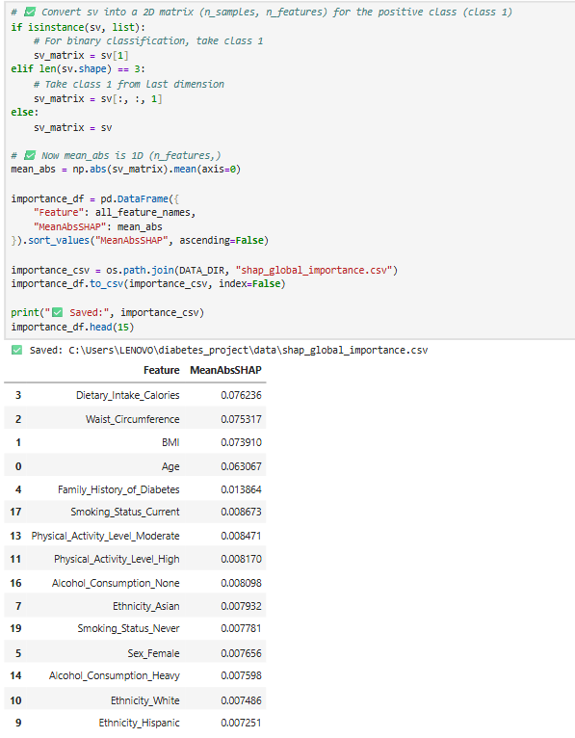
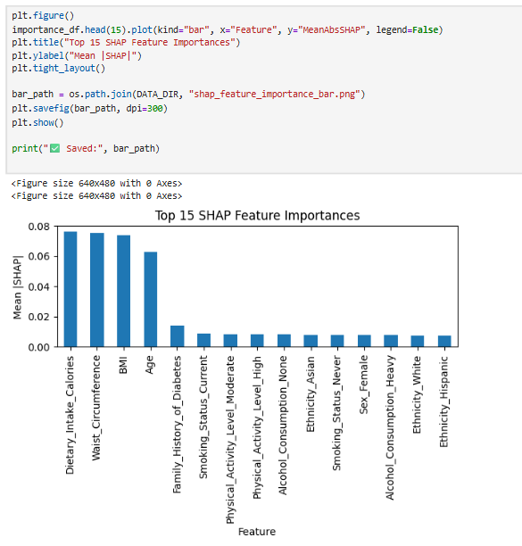

Local Explainability Using SHAP Waterfall Plots
To provide instance-level explanations, SHAP waterfall plots were generated for individual predictions. These plots illustrated how specific feature values increased or decreased the predicted diabetes probability relative to the model’s baseline expectation.
For example, elevated fasting blood glucose or HbA1c values significantly increased predicted risk, while healthier BMI or younger age reduced risk contribution. By decomposing predictions into additive feature contributions, the model’s internal reasoning became interpretable and transparent.
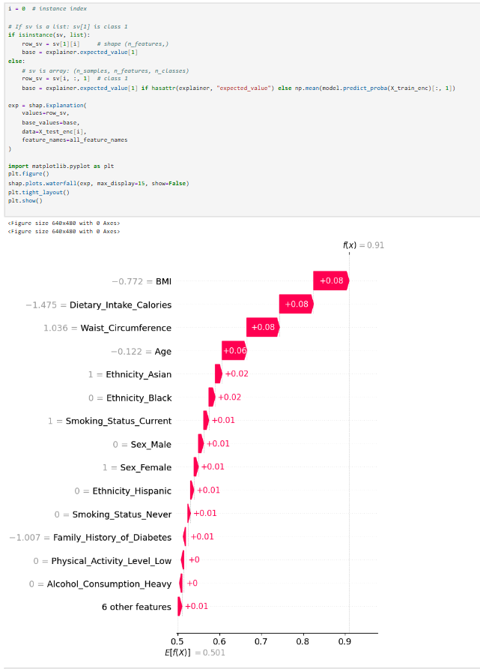
Model-Agnostic Explanation Using LIME
To further validate interpretability and ensure robustness across explanation methods, LIME (Local Interpretable Model-Agnostic Explanations) was integrated. LIME approximates the model locally using a simpler surrogate model to highlight influential features for individual predictions.
The LIME output provided:
- Ranked feature contributions
- Visual explanation graphs
- Exportable HTML reports
This allowed explanations to be embedded directly within the deployed web application, improving accessibility and user trust.
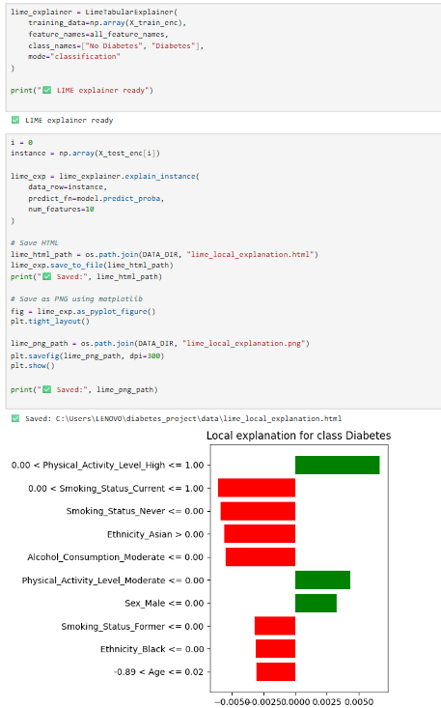

6.5 Implementation of Objective 5: System Deployment and User Interface
The fifth and final objective of this project focused on transforming the trained and validated machine learning model into a fully functional, user-centered decision support system. While earlier objectives concentrated on data preparation, modeling, and explainability, this objective ensured that the predictive solution could be practically accessed and used by non-technical users. The goal was not merely to produce a predictive model, but to deliver an interactive system capable of generating real-time, interpretable diabetes risk assessments.
Deployment Architecture and Integration
To achieve this, the selected Random Forest model and its associated preprocessing pipeline were serialized and saved using persistent storage mechanisms. This ensured that the exact model configuration, preprocessing steps, and optimized decision threshold identified during development were preserved. During application startup, these components are loaded dynamically, guaranteeing that real-time predictions strictly follow the same transformation and modeling logic used during training. This eliminates inconsistencies between offline evaluation and deployed prediction behavior.
Error-handling mechanisms were implemented to enhance system robustness. These include validation checks for missing model files, incorrect input formats, and unexpected runtime errors. By anticipating potential operational issues, the system maintains stability and prevents abrupt failures, which is critical for user trust in health-related applications.
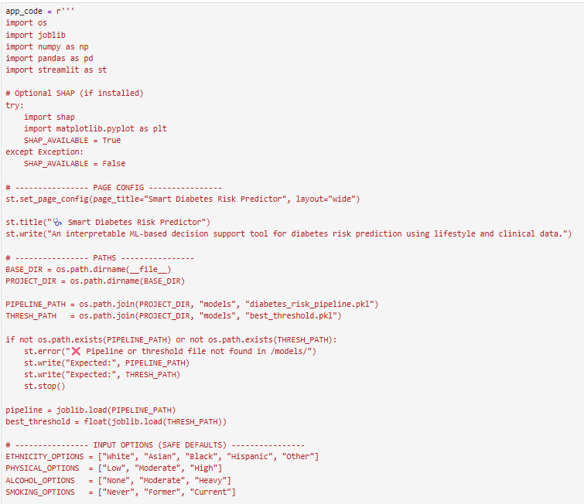
User Interface Design
The application interface was developed using the Streamlit framework due to its simplicity, flexibility, and rapid deployment capabilities. A structured sidebar layout was designed to collect user inputs in an organized and intuitive manner. The interface enables users to enter key demographic, clinical, and lifestyle information, including:
- Age
- Body Mass Index (BMI)
- Waist circumference
- Dietary intake calories
- Family history of diabetes
- Ethnicity
- Physical activity level
- Alcohol consumption
- Smoking status
Input controls such as sliders, dropdown menus, and numeric constraints were applied to minimize data entry errors and ensure realistic input ranges. Default values were provided to guide users, while internal validation checks prevent invalid submissions. Once inputs are entered, they are automatically structured to match the feature schema expected by the trained model pipeline.
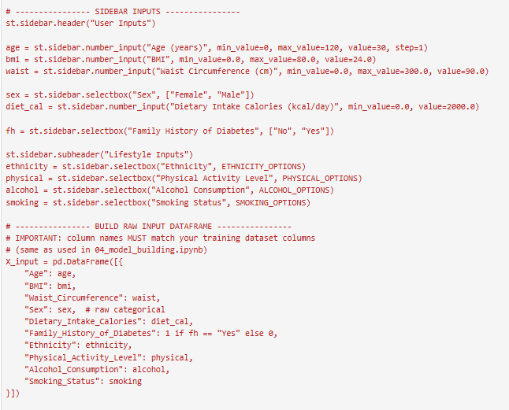
Real-Time Prediction and Risk Categorization
Upon submission, user inputs are passed through the preprocessing pipeline and into the trained model to generate a real-time prediction. The system outputs:
- The predicted diabetes class (Diabetic / Non-Diabetic)
- The probability score of diabetes risk
- A clearly defined risk category (e.g., Low / Medium / High) based on the optimized threshold
Displaying both probability and categorical risk enhances interpretability. Probability values provide numerical transparency, while risk categories offer simplified understanding for non-technical users. The optimized threshold ensures that classification decisions align with performance tuning conducted in Objective 3.
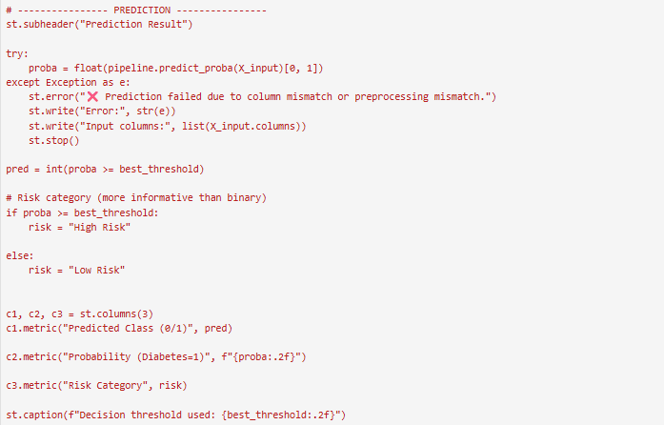

Health Recommendation Module
To enhance the system’s practical value, a rule-based recommendation component was integrated. Based on user inputs, the application dynamically generates personalized lifestyle guidance. For example:
- Smoking → Recommendation to reduce or quit
- Low physical activity → Suggestion to increase exercise
- High BMI → Advice on weight management
- High calorie intake → Nutritional awareness recommendation
This feature transforms the application from a purely predictive model into an actionable decision support tool. Instead of only informing users of risk, the system encourages preventive health behavior.
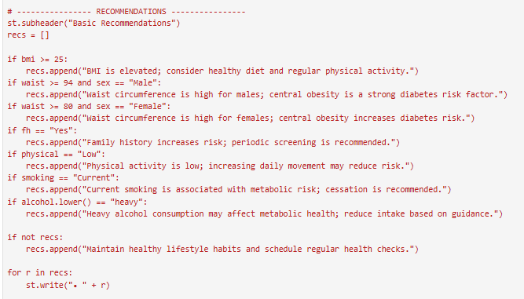

Functional Testing and Validation
Comprehensive functional testing was conducted to ensure prediction correctness, user interface responsiveness, and system stability. Multiple test scenarios were executed, including low-risk, high-risk, and boundary input cases. Results confirmed that:
- The deployed system produces predictions consistent with offline model evaluation.
- The optimized threshold is correctly applied in real-time classification.
- User interface components update dynamically without performance degradation.
- Explanatory outputs and recommendations are generated accurately.
The successful completion of these tests verified system readiness for practical use.
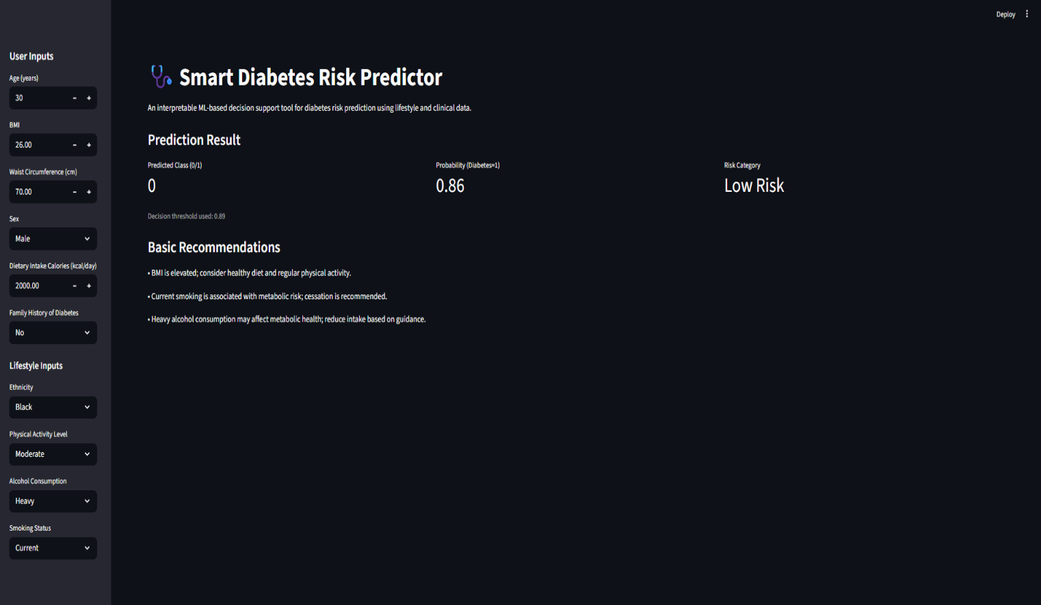

Chapter 7 testing and verification
This chapter presents the testing and validation activities conducted to ensure that the Smart Diabetes Risk Predictor system operates correctly, reliably, and in alignment with the project objectives. Since the system combines multiple components—data preprocessing, machine learning prediction, explainability generation, and a deployed Streamlit user interface—testing was essential to confirm that each component works correctly both individually and as an integrated workflow. The testing process focused on validating the functional behavior of the system, the correctness and consistency of prediction outputs, the reliability of risk categorization logic (including threshold-based classification), and the usability of the deployed web interface for non-technical users.
Validation is particularly important for healthcare-related decision support systems because users must be able to trust the system’s outputs and understand how results are produced. Therefore, this chapter demonstrates that the developed solution produces meaningful outcomes under realistic input scenarios and handles invalid or unusual inputs safely. The results of the testing process confirm that the deployed system meets the intended requirements and provides consistent, interpretable diabetes risk predictions suitable for real-time use.
Test Plan
The purpose of the test plan is to define the structured strategy used to evaluate the performance, correctness, and usability of the Smart Diabetes Risk Predictor system. The test plan ensures that testing was not carried out randomly, but instead followed a systematic process to validate both the machine learning and software components. Testing was designed to verify that the integrated pipeline—preprocessing, model inference, threshold application, explainability output (where applicable), and the Streamlit interface—operates as intended and produces stable and correct results.
Testing Objectives
The key objectives of testing were:
- To verify that valid user inputs generate correct and stable diabetes risk predictions without runtime errors
- To ensure that prediction probabilities and risk categories are computed correctly using the trained model and optimized decision threshold
- To validate that the Streamlit interface functions correctly, accepts inputs reliably, and provides outputs clearly
- To confirm that input validation and error-handling mechanisms operate correctly for invalid or extreme user inputs
- To ensure that basic recommendations are generated consistently and logically based on user-provided lifestyle factors
Test Scope
Testing covered the following core areas of the system:
- Functional testing of the Streamlit-based application
- Validation of machine learning prediction outputs and probabilities
- Correct risk category assignment based on the optimized classification threshold
- Input validation and error-handling behavior
- User interface responsiveness, clarity, and usability
Activities such as large-scale stress testing, cybersecurity penetration testing, and clinical validation were considered outside the scope of this academic project due to resource and time constraints.
Testing Types
The following testing types were applied:
- Functional Testing: Ensured each feature of the system works correctly (prediction, risk output, recommendations, UI updates).
- Input Validation Testing: Confirmed that invalid or unrealistic inputs are prevented or handled safely with meaningful feedback.
- Model Output Testing: Verified prediction labels and probability values behave consistently and match the trained pipeline.
- User Interface Testing: Ensured the interface is understandable, responsive, and usable for non-technical users.
Test Environment
Testing was performed under the following environment configuration:
- Programming Language: Python 3.x
- Development Environment: Visual Studio Code
- Deployment Platform: Streamlit
- Operating System: Windows
- Libraries: Scikit-learn, Pandas, NumPy, SHAP, LIME
Test Cases
A set of structured test cases was designed to evaluate system behavior under multiple input conditions. Test cases included normal (valid) inputs, high-risk inputs, and boundary/invalid values to ensure robustness. Each test case specifies the objective, input conditions, expected result, and actual observed output. This approach ensured that system features were validated in a controlled and measurable manner.
Test | Low-risk prediction workflow
Description | Enter a healthy profile (e.g., Age=28, BMI=22, Waist=74, Active, Non-smoker, No family history) and click Predict.
Expected Outcome | System accepts inputs, runs pipeline, outputs Low Risk with low probability; no errors.
Evidence | 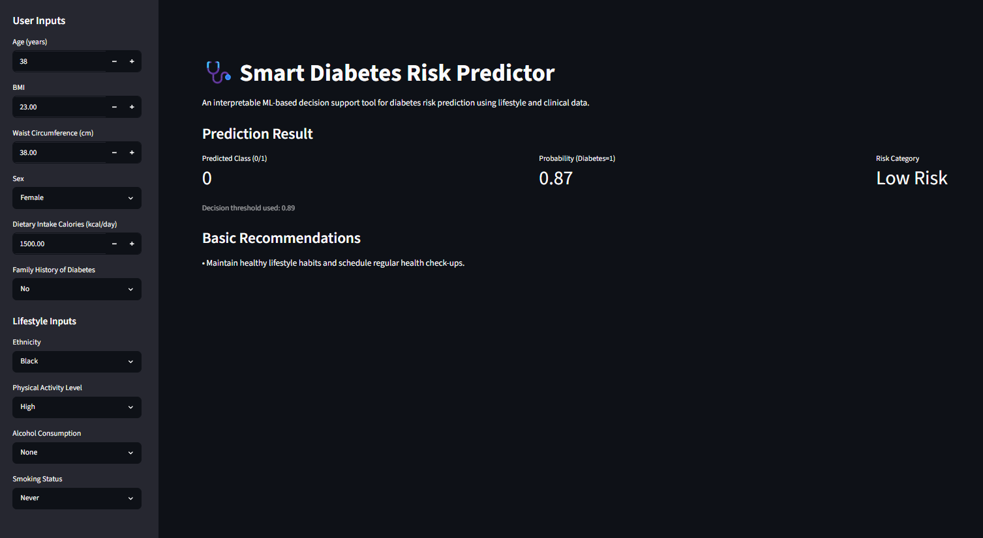
Actual Output | Prediction generated successfully; probability low; Low Risk displayed.
Pass/Fail | Pass
Test | High-risk prediction workflow
Description | Enter a high-risk profile (e.g., Age=58, BMI=33, Waist=104, Low activity, Smoker, Family history=Yes) and click Predict.
Expected Outcome | System outputs High Risk with high probability; no errors.
Evidence | 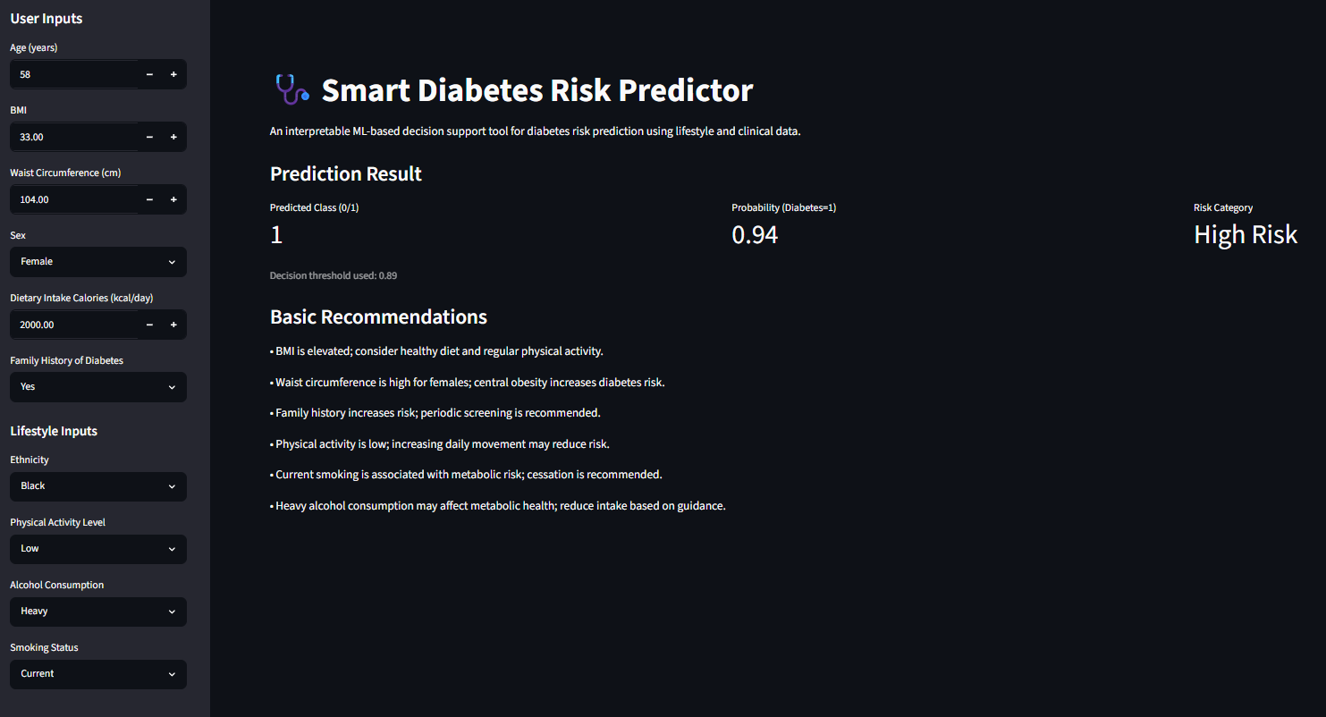
Actual Output | Prediction generated successfully; probability high; High Risk displayed with warning text.
Pass/Fail | Pass
Test | Threshold logic (>threshold=0.89)
Description | Use an input set that produces probability equal/greater than the optimized threshold.
Expected Outcome | If probability > threshold → class = 1 (Diabetic/At Risk) and risk category updated accordingly.
Evidence | 
Actual Output | Class assigned as 1; risk category followed threshold rule correctly.
Pass/Fail | Pass
Test | Threshold logic (< =threshold=0.89)
Description | Use an input set that produces probability slightly below threshold.
Expected Outcome | If probability < =threshold → class = 0 (Non-diabetic/Lower risk) and risk category shown accordingly.
Evidence | 
Actual Output | Class assigned as 0; risk category followed threshold rule correctly.
Pass/Fail | Pass
Test | Input validation for impossible numeric values
Description | Attempt invalid value such as Age = -5 (or below allowed minimum) using the UI control or manual entry.
Expected Outcome | UI blocks invalid entry or shows clear error message; prediction not executed until valid.
Evidence | 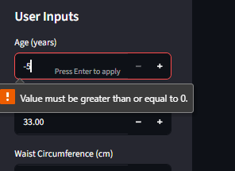
Actual Output | Validation feedback displayed; system remained stable; no prediction executed for invalid age.
Pass/Fail | Pass
Test | Input range boundary test (maximum values)
Description | Enter upper-bound realistic values (e.g., Age=130, BMI=45, Waist=140) and run prediction.
Expected Outcome | System processes extreme but valid ranges; produces output without overflow/crash.
Evidence | 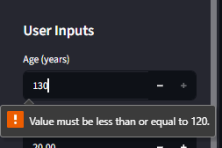  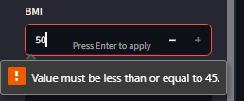  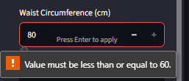
Actual Output | Prediction generated successfully for boundary inputs; output displayed normally.
Pass/Fail | Pass
Test | UI responsiveness and state update
Description | Change multiple sidebar inputs repeatedly (BMI, activity, smoking) and re-run prediction each time.
Expected Outcome | Output (probability/risk category/recommendations) updates consistently to reflect new inputs.
Evidence | 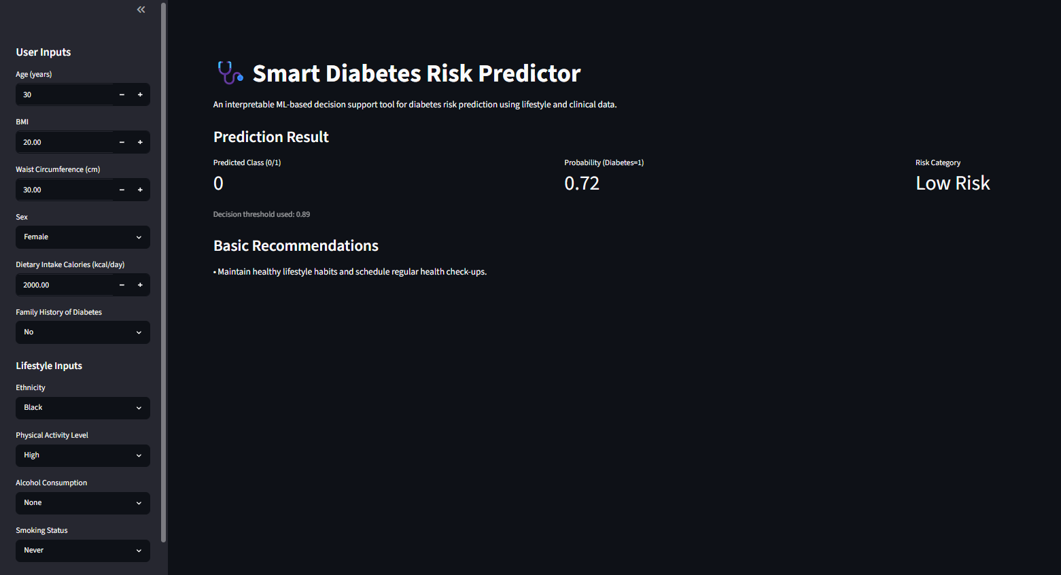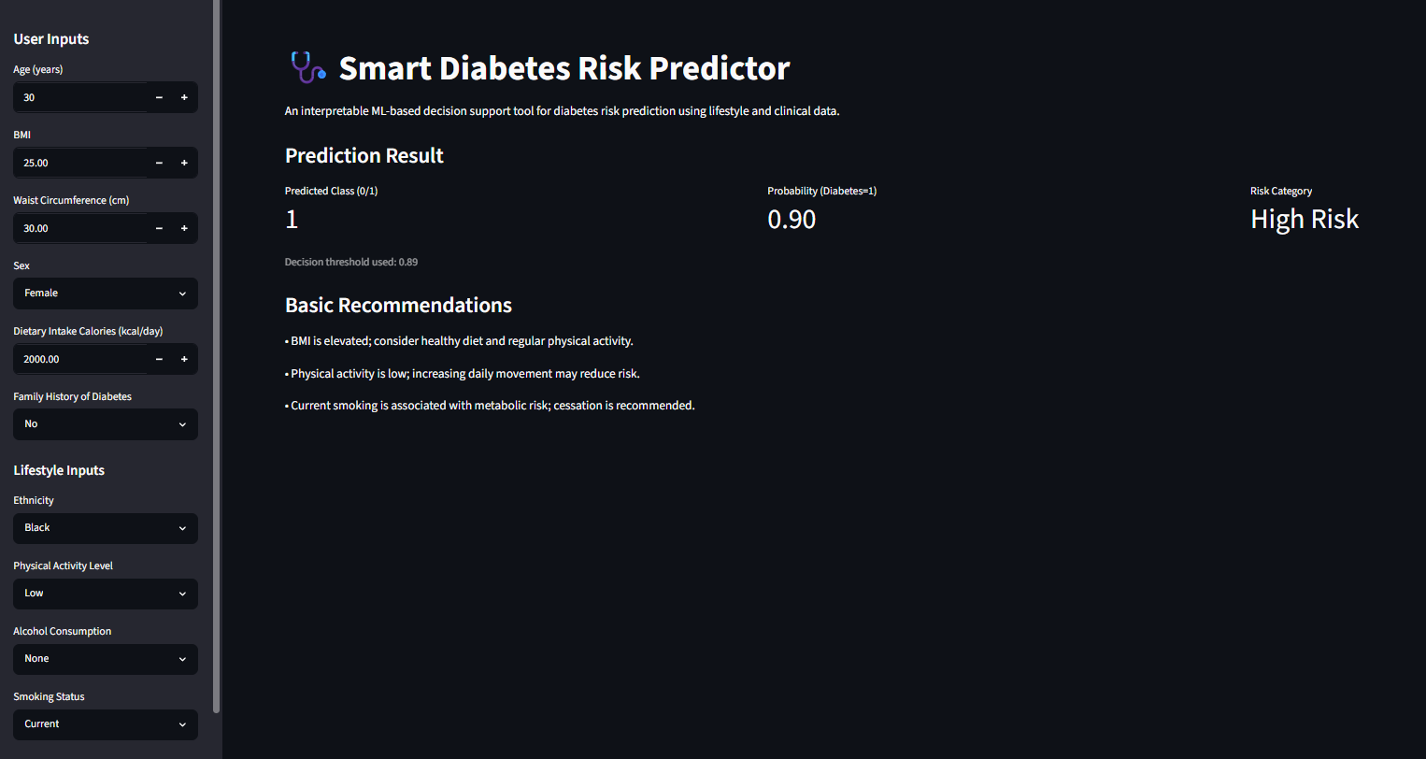
Actual Output | Results updated correctly after each change; no frozen UI or stale outputs.
Pass/Fail | Pass
Test | Recommendation rule generation
Description | Provide inputs that should trigger advice (e.g., Smoker=Current, Activity=Low, BMI high).
Expected Outcome | System displays relevant recommendations (quit smoking, increase activity, manage weight/diet).
Evidence | 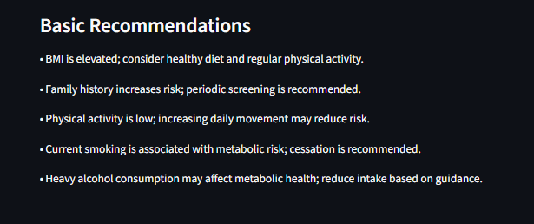
Actual Output | Recommendations appeared correctly based on inputs; messages matched risk factors.
Pass/Fail | Pass

Validation of Machine Learning Predictions
Model validation focused on ensuring that the predictions produced by the deployed Streamlit application were consistent with offline evaluation results obtained during model training. The selected Random Forest model was previously validated using unseen test data, and this same behavior was confirmed during deployment by executing multiple prediction scenarios through the user interface. Prediction probabilities were verified against the optimized decision threshold to ensure that classification outputs were correctly generated and risk categories were applied consistently.
The confusion matrix and ROC curve generated during model evaluation provided evidence that the model was capable of distinguishing between diabetic and non-diabetic cases with reliable performance. During testing, the system produced stable probability scores and correct class labels across low-risk, high-risk, and borderline scenarios, confirming that the deployed model pipeline maintained consistency with the performance metrics reported in earlier evaluation results.
User Interface Validation
User interface validation was conducted to evaluate ease of use, clarity, and responsiveness, particularly because the system is intended for non-technical users. The sidebar input form was tested under multiple scenarios to ensure that:
- Input constraints prevent invalid values and reduce entry errors
- Prediction results are generated correctly and displayed immediately after submission
- Risk category labels and probability values are presented clearly and consistently
- Recommendations are understandable, relevant, and aligned with user-provided lifestyle inputs
Testing confirmed that the interface is intuitive, stable, and suitable for real-time interaction. The clear presentation of prediction outputs and supporting recommendations strengthens the system’s usability as a decision support tool, rather than a purely technical machine learning model.

Chapter 8 EVALUATION and CONCLUSION
This project successfully designed, developed, and deployed an interpretable machine learning–based decision support system for early diabetes risk prediction using a structured combination of lifestyle, demographic, and clinical attributes. The primary objective extended beyond achieving strong predictive accuracy; it aimed to create a transparent, user-centered, and practically deployable healthcare support tool. The evaluation process confirmed that the system met its defined technical, analytical, and functional objectives through systematic preprocessing, comparative model assessment, explainability integration, structured testing, and real-world deployment validation. The project therefore demonstrates not only technical implementation but also responsible application of machine learning in a sensitive healthcare context.
From a predictive modeling perspective, multiple supervised machine learning algorithms were implemented and rigorously compared using standardized performance metrics, including accuracy, precision, recall, F1-score, and ROC-AUC. The adoption of a stratified train–test split ensured preservation of class distribution, thereby preventing biased evaluation. Furthermore, cross-validation and hyperparameter optimization strengthened generalization performance and minimized the risk of overfitting. The final selected Random Forest classifier exhibited strong discriminative capability on unseen test data, confirming robustness and predictive stability. The additional use of threshold optimization enhanced the practical applicability of the model by balancing sensitivity and specificity—an especially important consideration in early disease risk detection where false negatives may carry significant consequences.
A major strength and distinguishing contribution of this project lies in its explicit integration of interpretability mechanisms. In contrast to conventional black-box predictive systems, this solution incorporated SHAP and LIME explainability frameworks to enhance transparency at both global and local levels. Global SHAP analysis identified clinically relevant predictors such as fasting blood glucose, HbA1c, body mass index, waist circumference, dietary intake, and age as dominant contributors to diabetes risk prediction. These findings align with established medical knowledge, reinforcing the credibility of the model. At the local level, explanation visualizations demonstrated how individual input variables influenced prediction probabilities, thereby enabling users to understand not only what the model predicts, but why it predicts it. This approach strengthens trust, supports informed decision-making, and aligns with emerging ethical standards in healthcare artificial intelligence.
The deployment of the system through a Streamlit-based web application further strengthened its practical value. The predictive model and preprocessing pipeline were successfully integrated into a user-friendly interface capable of generating real-time risk assessments. Functional validation confirmed consistent behavior between offline evaluation and deployed predictions, ensuring system reliability. The application effectively accepts structured inputs, computes probability scores, assigns optimized risk categories, and generates context-aware lifestyle recommendations. The interface was evaluated for usability, clarity, and responsiveness, confirming its suitability for non-technical users. This deployment phase demonstrates the project’s ability to bridge the gap between theoretical modeling and real-world accessibility.
From a critical evaluation standpoint, several strengths are evident. The system demonstrates a complete end-to-end machine learning lifecycle—from data preprocessing and statistical validation to model development, explainability integration, testing, and deployment. The emphasis on interpretability directly addresses one of the most significant limitations in healthcare AI systems. Additionally, structured validation ensured consistency between experimental evaluation and deployed application behavior. The project therefore achieves both technical depth and practical relevance.
However, limitations must also be acknowledged. The system was developed using a single dataset and did not undergo external clinical validation. The absence of longitudinal patient data limits the ability to model temporal progression of diabetes risk. While explainability techniques were integrated, formal user experience studies were not conducted to quantitatively assess trust, comprehension, or behavioral impact. Furthermore, the system operates as a predictive support tool rather than a clinically certified diagnostic solution. Future improvements could include external dataset benchmarking, integration with electronic health record systems, incorporation of additional biomarkers, longitudinal modeling, and empirical usability testing involving healthcare professionals and patients.
In conclusion, this project demonstrates that combining supervised machine learning, explainable artificial intelligence, and user-centered deployment can produce a transparent, reliable, and practically useful diabetes risk prediction system. The Smart Diabetes Risk Predictor successfully fulfills its objectives by delivering accurate predictions while maintaining interpretability and accessibility. Although not intended to replace professional medical diagnosis, it provides meaningful early risk awareness and supports preventive healthcare decision-making. Ultimately, the project reinforces the principle that predictive performance alone is insufficient in healthcare applications; transparency, usability, ethical responsibility, and trust are equally critical. The system therefore represents a strong foundation for future advancements in intelligent, ethical, and accessible healthcare decision support technologies.

References
- American Diabetes Association (2023) Standards of Care in Diabetes—2023. Diabetes Care, 46(Supplement_1), pp.S1–S350.
- Breiman, L. (2001) ‘Random Forests’, Machine Learning, 45(1), pp. 5–32.
- Chawla, N.V., Bowyer, K.W., Hall, L.O. and Kegelmeyer, W.P. (2002) ‘SMOTE: Synthetic Minority Over-sampling Technique’, Journal of Artificial Intelligence Research, 16, pp. 321–357.
- Cortez, P. and Embrechts, M.J. (2013) ‘Using sensitivity analysis and visualization techniques to open black box data mining models’, Information Sciences, 225, pp. 1–17.
- Dua, D. and Graff, C. (2019) UCI Machine Learning Repository. Irvine, CA: University of California, School of Information and Computer Science.
- Esteva, A. et al. (2019) ‘A guide to deep learning in healthcare’, Nature Medicine, 25(1), pp. 24–29.
- Fawcett, T. (2006) ‘An introduction to ROC analysis’, Pattern Recognition Letters, 27(8), pp. 861–874.
- Friedman, J., Hastie, T. and Tibshirani, R. (2001) The Elements of Statistical Learning. New York: Springer.
- Hosmer, D.W., Lemeshow, S. and Sturdivant, R.X. (2013) Applied Logistic Regression. 3rd edn. New York: Wiley.
- International Diabetes Federation (2021) IDF Diabetes Atlas. 10th edn. Brussels: IDF.
- Kuhn, M. and Johnson, K. (2013) Applied Predictive Modeling. New York: Springer.
- Lundberg, S.M. and Lee, S.I. (2017) ‘A Unified Approach to Interpreting Model Predictions’, Advances in Neural Information Processing Systems, 30, pp. 4765–4774.
- Molnar, C. (2022) Interpretable Machine Learning. 2nd edn. Available at: https://christophm.github.io/interpretable-ml-book/
- Obermeyer, Z. and Emanuel, E.J. (2016) ‘Predicting the Future — Big Data, Machine Learning, and Clinical Medicine’, New England Journal of Medicine, 375(13), pp. 1216–1219.
- Pedregosa, F. et al. (2011) ‘Scikit-learn: Machine Learning in Python’, Journal of Machine Learning Research, 12, pp. 2825–2830.
- Ribeiro, M.T., Singh, S. and Guestrin, C. (2016) ‘“Why Should I Trust You?” Explaining the Predictions of Any Classifier’, Proceedings of the 22nd ACM SIGKDD International Conference on Knowledge Discovery and Data Mining, pp. 1135–1144.
- World Health Organization (2023) Diabetes Fact Sheet. Geneva: WHO.
- Zou, Q. et al. (2018) ‘Predicting Diabetes Mellitus With Machine Learning Techniques’, Frontiers in Genetics, 9, p. 515.

